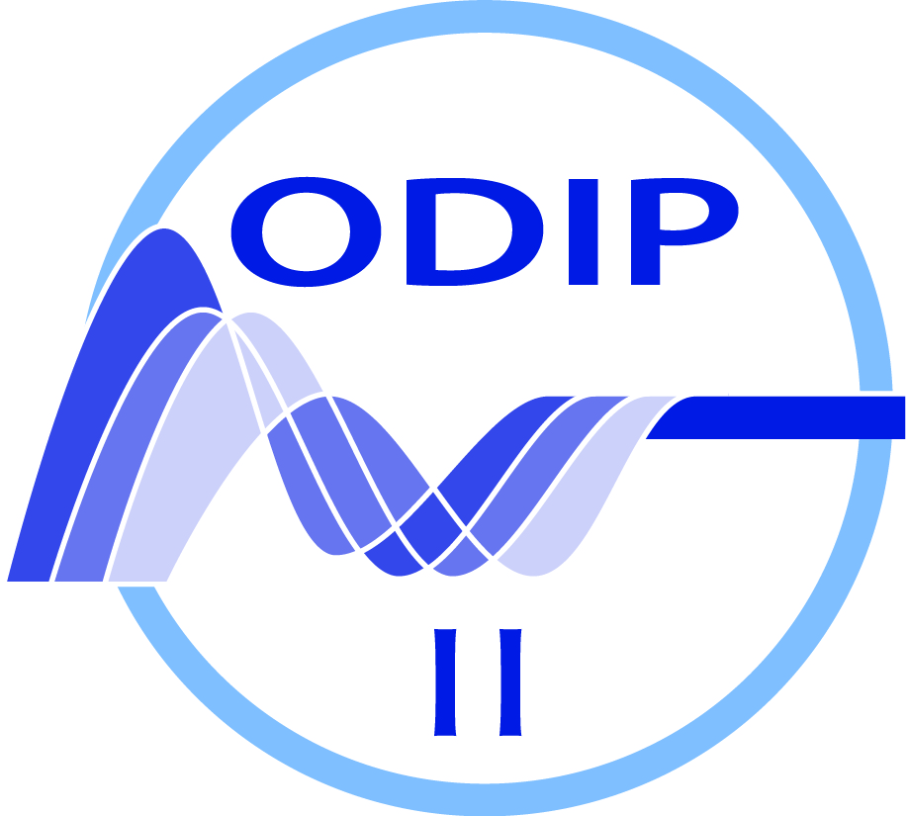

Ocean Data Interoperability Platform

Deliverable D3.4: Progress and Results from Prototype Developments 2

Workpackage | WP3 | ODIP Prototypes
Author (s) | Dick M.A. Schaap, Peter Thijsse |  | MARIS
Author (s) | Alexandra Kokkinaki |  | BODC
Author (s) | Adam Leadbetter, Rob Thomas |  | MI
Author (s) | Simon Jirka, Christian Autermann |  | 52°North
Author (s) | Enrico Boldrini, Stefano Nativi, Fabrizio Papeschi |  | CNR
Author (s) | Friedrich Nast, Filip Loeckle |  | BSH
Author (s) | Jay Pearlman |  | IEEE
Authorized by | Helen Glaves |  | NERC
Reviewer
Doc Id | ODIP II_D3.4
Dissemination Level | PUBLIC
Issue | 1.0
Date | 15 March 2018

Document History
Version | Author(s) | Status | Date | Comments
1.0 | Dick M.A. Schaap (MARIS) | DRAFT | 15 March 2018 | First draft using contributions from several partners

Contents
Executive Summary 4
1. Introduction 6
2. Results of the five prototypes 7
2.1 ODIP Prototype 1+ 7
2.1.1 Establishing semantic discovery interoperability between the three regional catalogue services 7
2.1.2 Establishing horizontal interoperability by developing an ODIP interface using WMS – WFS 17
2.2 ODIP Prototype 2+ 18
2.2.1 Further population of CSR directory 18
2.2.2 Mapping and publishing CSR as Linked Data in synergy with SeaDataCloud 21
2.3 ODIP Prototype 3+ 35
2.3.1 Evaluation of Sensor Web Technologies for Marine Applications 36
2.3.2 Analysing the handling of large volumes of data within SWE-based infrastructures 43
2.3.3 Use of lightweight technologies such as JSON and REST as complementary technologies: 44
2.3.4 Use of RDF-based approaches – vocabularies - for supporting the discovery of marine sensors and data sets 44
2.3.5 Synchronising efforts for metadata/SensorML Editors: 45
2.3.6 Linking between Sensor Web and Global Infrastructures such as GEOSS 48
2.3.7 Promoting Sensor Web Technology 48
2.4 ODIP Prototype 4 49
2.4.1 Analysis 49
2.4.2 Architecture for VRE for SeaDataCloud 50
2.4.3 Notebook services 54
2.4.4 DIVA software as one of the VRE processing engines 55
2.5 ODIP Prototype 5 57
3. Documenting and Sharing Best Practices - The Challenge, Status and Future Vision 62
3.1 Challenges 62
3.2 The Ocean Best Practice System 63
3.3 System Evolution – from Concept to Implementation 65
3.4 Summary 67
3.5 References 67
4. Appendix A: Terminology 70
5 Appendix B: RDF/XML examples of CSR: 76

Executive Summary
The “Extending the Ocean Data Interoperability Platform” project (ODIP II) is promoting the development of a common global framework for marine data management by developing interoperability between existing regional e-infrastructures of Europe, USA and Australia and towards global infrastructures such as GEOSS, IOC-IODE and POGO.
This has been done in practice by organising four international workshops over the three years lifetime of the project to present, compare and discuss approaches and standards applied. The workshops involving relevant domain experts provided insights into commonalities and differences and contributed to identify opportunities for the development of common standards and interoperability solutions.
As a follow-up ODIP prototypes projects were formulated and worked out in order to evaluate and test selected potential standards and interoperability solutions for establishing and demonstrating improved interoperability between the regional infrastructures and towards global infrastructures.
Things got more complicated in ODIP II in comparison to ODIP as only EU partners managed to land extra funding, while contributions from USA and Australian partners had to be brought up from their own institute funds. This gave even more emphasis on the approach that actual ODIP II prototype developments should be done largely by leveraging on the activities of current regional projects and initiatives of the ODIP II partners. The ODIP II prototype projects were formulated taking these constraints into account.
The first strand of ODIP II prototypes was agreed after the 1st ODIP II Workshop as focusing on expanding the three prototype projects from the predecessor ODIP project. The specifications for the expansion have been documented in the ODIP II Deliverable D3.1. In summary, the targets for the expansions concerned:

  - ODIP 1+: Analysing options for establishing semantic interoperability between the three regional discovery and access services at metadata level and establishing horizontal interoperability by developing an ODIP interface using WMS – WFS and possibly OpenSearch; and analysing the set-up of transformation services for converting the SeaDataNet ODV format to the Observations & Measurements (O&M) data model following INSPIRE guidelines and to an extended SeaDataNet NetCDF (CF) data format. Lead by MARIS with contributions by European, USA and Australian partners;
  - ODIP 2+: Further population of the Cruise Summary Reports database for USA cruises from R2R, initiating contributions for Australian cruises, and including ICES legacy CSRs; analysing the upgrading of the CSR metadata format, Schema and related tools and services following earlier R2R suggestions; and publishing CSRs also in RDF by means of a SPARQL endpoint. Lead by BSH with contributions by European, USA and Australian partners;
  - ODIP 3+: Establishing OGC Sensor Web Enablement (SWE) standards for facilitating the interoperable sharing of oceanographic observation data and metadata; analysing the handling of large volumes of data within SWE-based infrastructures, use of lightweight technologies such as JSON and REST as complementary technologies and use of RDF-based approaches for supporting the discovery of marine sensors and data sets; and synchronising efforts for metadata/SensorML Editors. Lead by 52°North with contributions by European, USA and Australian partners.

The fourth ODIP II prototype was agreed at the 3rd ODIP II Workshop aiming at the concept of collaborative cloud workspaces for functions such as computing, analyzing, accessing data, and visualization:

- ODIP 4: ‘the Digital Playground’ to explore, review, and formulate common solutions and best practices for setting up and configuring cloud based Virtual Research Environments in the marine domain, dealing with a great variety of data types, processes, user classes, big data, and both operational and delayed mode data services.
The fifth ODIP II prototype was formulated and agreed in between the 3rd and 4th ODIP II Workshops and deals with marine biology:

- ODIP 5: ‘Integration of data management for biological and physicochemical marine data’ to analyse the usability of the MEOP database ("Marine Mammals Exploring the Oceans Pole to Pole") within the context of the OBIS-ENV-DATA scheme and to assess if both data schemes can match in order to exchange information between the physical environment and the occurrence of a certain species between both data systems.
The specifications and work plans of prototypes 4 and 5 have been documented in ODIP II Deliverable D3.2.
The earlier mentioned funding complication implicated that additional developments outside of ongoing projects in practice have been done largely by the European ODIP II partners, while the USA, Canadian and Australian partners contributed during the Workshops and in between with bringing in their experiences and views and acting as sparring partners for giving feedback on the ongoing prototype developments. Fortunately the European partners in practice could exploit synergy options with the EU supported SeaDataCloud project which started in November 2016 as successor to the SeaDataNet II project.
The activities undertaken and progress made with the first 3 prototypes up till the end of Month 18 have already been reported in ODIP II Deliverable D3.3. This also covers the progress and results from the cross-cutting topic on vocabularies.
This ODIP II Deliverable D3.4 gives a report on the activities undertaken and the results achieved in the second 18 months of the ODIP II project for finalizing the three ODIP II expansion projects and working out the second strand of ODIP II prototype projects.

Introduction
This ODIP II Deliverable D3.4 gives a report on the activities undertaken and the results achieved in the second 18 months of the ODIP II project for finalizing the three ODIP II expansion projects and working out the second strand of ODIP II prototype projects. In addition, the activities and progress made with establishing the ‘Ocean Best Practices System (OBP-S) are reported.

2. Results of the five prototypes
As part of the ODIP II project 5 prototypes have been undertaken. The progress made with the first 3 prototypes up till the end of Month 18 have already been reported in ODIP II Deliverable D3.3. This chapter reports on the results achieved in the second 18 months for finalizing the first three prototypes and working out numbers 4 and 5.

ODIP Prototype 1+
The earlier ODIP Prototype 1 has been the basis for the expansions and it concerns interoperability of regional discovery services (SeaDataNet, NCEI and AODN) towards the global GEOSS and ODP portals. In the final situation there is metadata brokerage at collections level and entries are included in GEOSS and ODP with return links to granule level at regional portals and their data access options.

The ODIP Prototype 1+ has been led by MARIS with contributions from partners from the three regions. Activities have been undertaken for earlier defined targets of the ODIP Prototype 1+ project. In particular for:

- establishing semantic discovery interoperability between the three regional catalogue services
- establishing horizontal interoperability by developing an ODIP interface using WMS – WFS.

Establishing semantic discovery interoperability between the three regional catalogue services

The scope of ODIP II is to interconnect marine communities worldwide, in order to allow global users to discover and access data from regional data providers in Europe, United States and Australia.

Brokering architecture

Prototype 1+ is based on a brokering architecture that enables interoperability between different clients (i.e. international portals) and services (i.e. regional data providers and Rosetta Stone translation service) (see Figure 2.1.1). The brokering framework here in use is the GEODAB (http://www.geodab.net/), developed by CNR-IIA and used as well as a key component of the Global Earth Observation System of Systems (GEOSS), the intergovernmental effort led by the Group on Earth Observations (GEO) to build a global system able to discover and access data from all the heterogeneous sensors currently deployed in the Earth Science domain.

The GEODAB component takes charge of mediation and harmonization of the different protocols and data models being used in ODIP, to enable interoperability between the different interconnected web components, e.g.:

- Regional data providers
  - SeaDataNet
  - USA NCEI
  - IMOS AODN
- Rosetta Stone translation service
- International portals
  - GEOSS portal
  - IODE ODP portal
  - ODIP portal

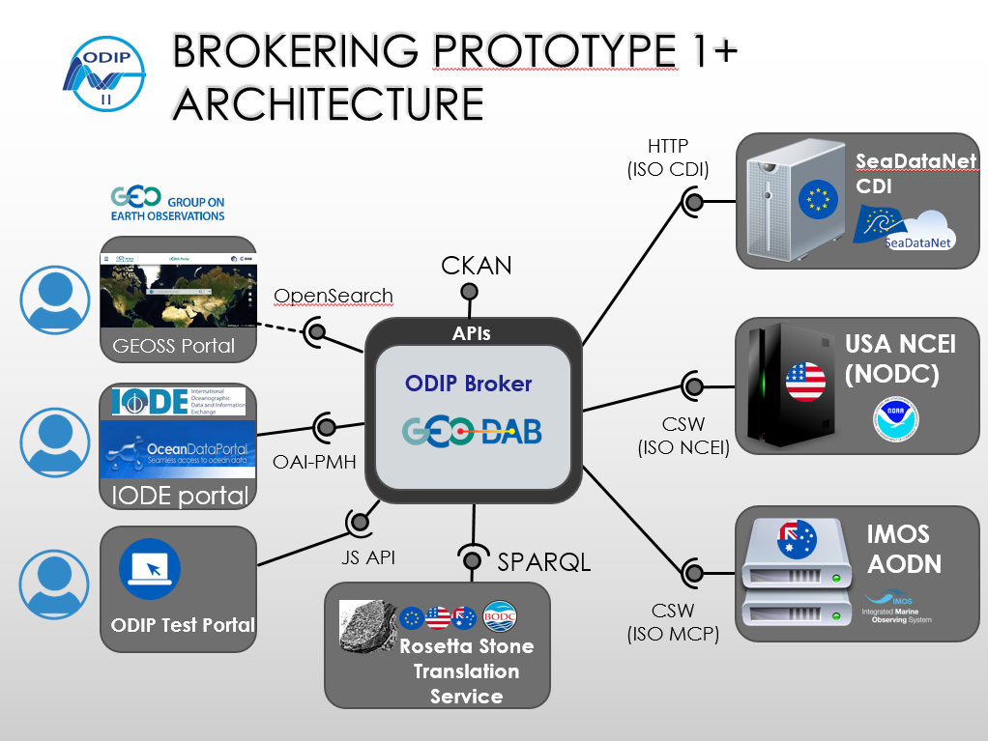
Figure 2.1.1 Brokering prototype 1+ architecture: main web components and their inter-connections
Each component exposes or accesses a specific web service interface, characterized in general by a specific protocol and data model. Example given the CSW/ISO interface is defined by the OGC Catalogue Service for the Web protocol, and by the ISO 19115 Geographic data model and its XML implementation ISO 19139.

The ODIP broker is able to expose or access the needed web service interfaces, in order to enable interconnection between ODIP components. This is done through specific subcomponents called profilers (if the interface is being exposed) and accessors (if the interface is being accessed). This modular and flexible architecture implemented by the ODIP broker makes it easier to be extended even to implement future interfaces.

As an example, the following standard web service interfaces are made available by specific profiler components to programmatically access the ODIP broker content:
OAI-PMH: http://seadatanet.geodab.eu/gi-cat/services/oaipmh
CSW/ISO: http://seadatanet.geodab.eu/gi-cat/services/cswiso

MARIS has recently harvested the XML output of each of the three regional services using OAI-PMH which resulted in:
- 24578 XML entries from NCEI
- 557 XML entries from SeaDataNet
- 185 XML entries from AODN

The following sections describe each component of the resulting ODIP brokering prototype 1+.

SeaDataNet data provider
SeaDataNet is a distributed Marine Data Infrastructure for the management of large and diverse sets of data deriving from in situ of the seas and oceans. Professional data centres, active in data collection, constitute a Pan-European network providing on-line integrated databases of standardized quality. The SeaDataNet CDI service (http://seadatanet.maris2.nl/cdi_aggregation/sdn-cdi-aggr-seadatanet_v3.xml) implements an aggregated inventory of the SeaDataNet data offering, organized at Dataset Collection level by theme and originating organization. Collections metadata records are documented using the SeaDataNet CDI profile of ISO 19115 and its XML encoding based on ISO 19139 (https://www.seadatanet.org/Standards/Metadata-formats/CDI). Different SeaDataNet metadata elements are documented according to restricted domains defined by specific SeaDataNet vocabularies:
- SeaDataNet Common Vocabularies as hosted by NERC-BODC for various attributes such as discovery parameters, platforms, sea regions, access restriction policies, coordinate reference systems, data transport formats, parameter usage vocabulary, units, instrument types, instruments, Climate and Forecast (CF) standard names, ISO Country codes, and ICES platform codes;
- SeaDataNet EDMO codes for organisations
- SeaDataNet EDMERP codes for projects
- SeaDataNet CSR codes for Cruise Summary Reports

The data centres in the SeaDataNet infrastructure might use other vocabularies in their own local systems, but as SeaDataNet partner each connected data centre has to map its local vocabularies to those used in SeaDataNet for achieving a harmonised population of the SeaDataNet metadata directories and data resources.

USA NCEI data provider
NOAA’s National Centers for Environmental Information (NCEI) hosts and provides access to one of the most significant archives on earth, with comprehensive oceanic, atmospheric, and geophysical data. From the depths of the ocean to the surface of the sun and from million-year-old ice core records to near-real-time satellite images, NCEI is the US leading authority for environmental information. The NCEI catalogue of metadata is available through a CSW ISO interface (http://data.nodc.noaa.gov/geoportal/csw/discovery?). Records are described according to the comprehensive profile of ISO 19115-2 and its ISO-19139 based XML encoding. NCEI make use of the following vocabularies to restrict the domain of specific metadata elements:
- NASA’s Global Change Master Directory, for earth science, data centres, locations, instrument/sensors, platforms/sources and projects
- NODC Vocabularies for people, projects, institutions, ICES platform codes, sea names, data types, observations, instruments, ISO country codes, and Climate and Forecast (CF) standard names
Next to these primary vocabularies, also use is made of other vocabularies:
- Ocean Exploration and Research (OER) Discovery Keywords
- Getty Thesaurus of Geographic Names
- Library of Congress Subject Headings
- SeaDataNet Common Vocabularies
- Geographic Names Information System
- GEBCO Gazetteer of Undersea Feature Names

NOAA and its data centres, recently bundled as National Centres for Environmental Information (NCEI), oversee and manage an enormous data collection, which also goes back a long time. This implicates that various code lists have been used over time and that harmonising these to one common set of vocabularies will have major consequences for the marking up of the large data collections and their metadata.

IMOS AODN data provider
The Australian Ocean Data Network (AODN) is an interoperable online network of marine and climate data resources. IMOS and the 6 Australian Commonwealth agencies form the core of the AODN. Increasingly, though, universities and state government offices are offering up data resources to the AODN, and delivery of data to the AODN is being written in to significant research programs e.g. National Envronmental Science Program Marine Biodiversity Hub and the Great Australian Bight research program. The marine data collections are made freely available to the public. Data covers a wide range of parameters in different ocean environments collected from ocean-going ships, autonomous vehicles, moorings and other platforms.
AODN catalogue of metadata is available through a CSW ISO interface (https://catalogue-portal.aodn.org.au/geonetwork/srv/eng/csw). Records are described according to the Marine Community Profile (MCP) of ISO 19115 (http://mcp-profile-docs.readthedocs.io/en/stable/preface.html) and its ISO-19139 based XML encoding.
The Australian Integrated Marine Observing System (IMOS) makes use of the SeaDataNet Common Vocabularies, where-ever possible. The participation in ODIP has been very favourable for this decision and IMOS has become also a regular contributor for new terms to these vocabularies. Furthermore IMOS has become the Australian national node for entering and maintaining Australian organisations (so far > 250) in the SeaDataNet EDMO directory. While developing the overarching Australian Ocean Data Network (AODN) it appeared that many of the larger Australian institutions (e.g. CSIRO Oceans and Atmosphere, AIMS, Australian Antarctic Division, GA, Bureau of Meterology) already use some form of in-house vocabularies. Many of these vocabularies are not formalized, published or well governed. But, these terminologies are often integral to how their internal (or public-facing) systems operate. Therefore IMOS has begun with developing mappings between institutional terminologies and the AODN common vocabulary as the primary means of creating standardized vocabulary usage within metadata that is required to underpin the AODN data delivery infrastructure.
Rosetta Stone translation service
BODC created a prototype service called Rosetta Stone service, to enable translations between terms that belong to different vocabularies. The target vocabularies were
- NERC Vocabulary Server (NVS), Europe
- AODN Vocabularies, Australia
- NODC Vocabularies, USA
In order to implement it, BODC carefully selected some terms from the following categories/vocabularies
- platforms
- instruments
- organisations
- parameters
These were then mapped through relation properties owl:sameAs and skos:broader as shown in the following table.

NVS2.0 |  |  |  | External Vocabularies
Vocab Name | Code | PrefLabel | Relation | External link | prefLabel
P02 | PSAL | Salinity of the water column | SYN | https://www.nodc.noaa.gov/cgi-bin/OAS/prd/datatype/details/307 | SALINITY
P02 | TEMP | Temperature of the water column | SYN | https://www.nodc.noaa.gov/cgi-bin/OAS/prd/datatype/details/373 | WATER TEMPERATURE
P02 | ASLV | Sea Level | SYN | https://www.nodc.noaa.gov/cgi-bin/OAS/prd/datatype/details/312 | SEA LEVEL
P02 | ASLV | Sea Level | SYN | http://vocab.aodn.org.au/def/discovery_parameter/entity/643 | Sea surface height above geoid
L05 | LAB30 | salinometers | SYN | https://www.nodc.noaa.gov/cgi-bin/OAS/prd/insttype/details/75 | generic salinometer
L05 | WPS | water pressure sensors | BRD | https://www.nodc.noaa.gov/cgi-bin/OAS/prd/insttype/details/207 | pressure sensors
C75 | UAA | University of Alaska Anchorage Department of Biological Sciences | SYN | https://www.nodc.noaa.gov/cgi-bin/OAS/prd/institution/details/972;

The Rosetta Stone translation service has been developed as a SPARQL endpoint (http://vocab.nerc.ac.uk/sparql/sparql). The Rosetta Stone is thus able to capture knowledge of which terms are identical to, similar or specialisations of other terms used across the regional systems (anyway SeaDataNet, NCEI and AODN) and publish this knowledge in a machine to machine system based on SPARQL.
Example given, sea level terms from different vocabularies, with identical meaning:
NODC
https://www.nodc.noaa.gov/cgi-bin/OAS/prd/datatype/details/312 (SEA LEVEL)
SeaDataNet
http://www.seadatanet.org/urnurl/SDN:P02::ASLV/ (Sea level)
AODN
http://vocab.aodn.org.au/def/discovery_parameter/entity/643 (Sea surface height above geoid)
Queries can be executed against the SPARQL endpoint e.g. to retrieve all the identical terms from different vocabulary given a specific term in use in a specific regional vocabulary.
Common translation between terms coming from different vocabularies have been identified and inserted in Rosetta Stone, however a full mapping of the three vocabularies has not yet been completed, requiring extra effort. This will be done later in the framework of the EU SeaDataCloud project. Especially the mappings from and to NCEI represent a considerable challenge, also taking into account that NCEI is using a very rich metadata format approach with many additional attributes in comparison with the SeaDataNet CDI and AODN MCP metadata formats. The latter have been set up from their start as common core implementations of the ISO19115 standard with attributes supported by controlled terms, where-ever possible. In that sense one can say that both SeaDataNet CDI and AODN MCP formats are more lean and contain less information than the NCEI metadata format which has been developed and populated by bringing together legacy metadata systems.

The pilot Rosetta stone currently works for the following mappings
- NODC to NVS
- AODN to NVS
To support NODC to AODN or AODN to NODC mappings it is necessary that NODC / AODN will register these in their SPARQL endpoint.

GEOSS portal
The GEOSS Portal, implemented and operated by the European Space Agency (ESA) as a member of GEO, constitutes a single Internet access point for Users to connect to Earth Observations (data, information, knowledge, algorithms, models, services, etc.) relevant to all parts of the globe to strengthen the monitoring of the state of the Earth, to increase our understanding of Earth processes and enhance predictive capabilities that underpin sound decision-making. It allows users to discover, access and use Earth Observations via the GEOSS and facilitates the sharing of environmental data, information and knowledge collected from the large array of observing systems contributed by countries and organisations within GEO. The GEOSS Portal (http://www.geoportal.org) is a component of the GEOSS Platform (formerly known as GCI) and connects users via other GEOSS platform components (in particular CNR-IIA GEODAB), to the GEOSS resources registered by the GEOSS resource providers.

Technical tests has been successfully accomplished to make the GEOSS portal discover ODIP datasets by querying the OpenSearch interface published by the ODIP broker. After submitting a formal request to GEOSS to activate this link (dashed in Figure 2.1.1) data sets originated by USA NCEI and IMOS AODN will be made available for discovery to all the global users of GEOSS portal (note that SeaDataNet datasets are already present in GEOSS).

ODP portal
The International Oceanographic Data and Information Exchange (IODE) programme of IOC UNESCO, through its distributed network of National Oceanographic Data Centres (NODCs), is establishing the Ocean Data Portal (ODP) (www.oceandataportal.org) to facilitate seamless access to marine data/services and to promote the exchange and dissemination of marine data and services. ODP is currently harvesting ODIP datasets through the OAI-PMH interface published by the broker.

ODIP test portal
An ODIP test portal has been developed and deployed (http://odip-prototype.essi-lab.eu/broker/odip/search) during ODIP II to demonstrate the ODIP broker discovery functionalities at full through a user friendly web interface which includes semantic capabilities.
The user is presented with a map of the Earth on which matching results are represented with their geographic extent (bounding boxes or point locations). The user can constraint the result set using one or more of the available constraints: textual search term, geographic extent, temporal extent and data originator (see Figure 2.1.2) are common and general search criteria that can be selected using the test portal graphical widgets. The left section of the ODIP test portal provides a paginated list of matching records. Each record is described using a brief overview including the more salient metadata elements, such as title, abstract and graphical preview.

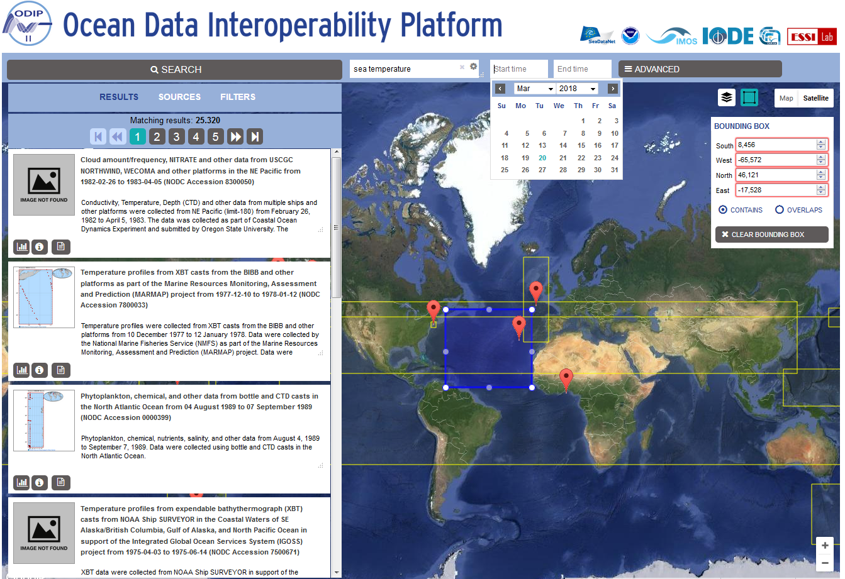
Figure 2.1.2 ODIP test portal: common constraints can be used to restrict the matching result set
Specific metadata elements that are particularly of interest for ODIP are represented as well (ODIP target elements).

They are:

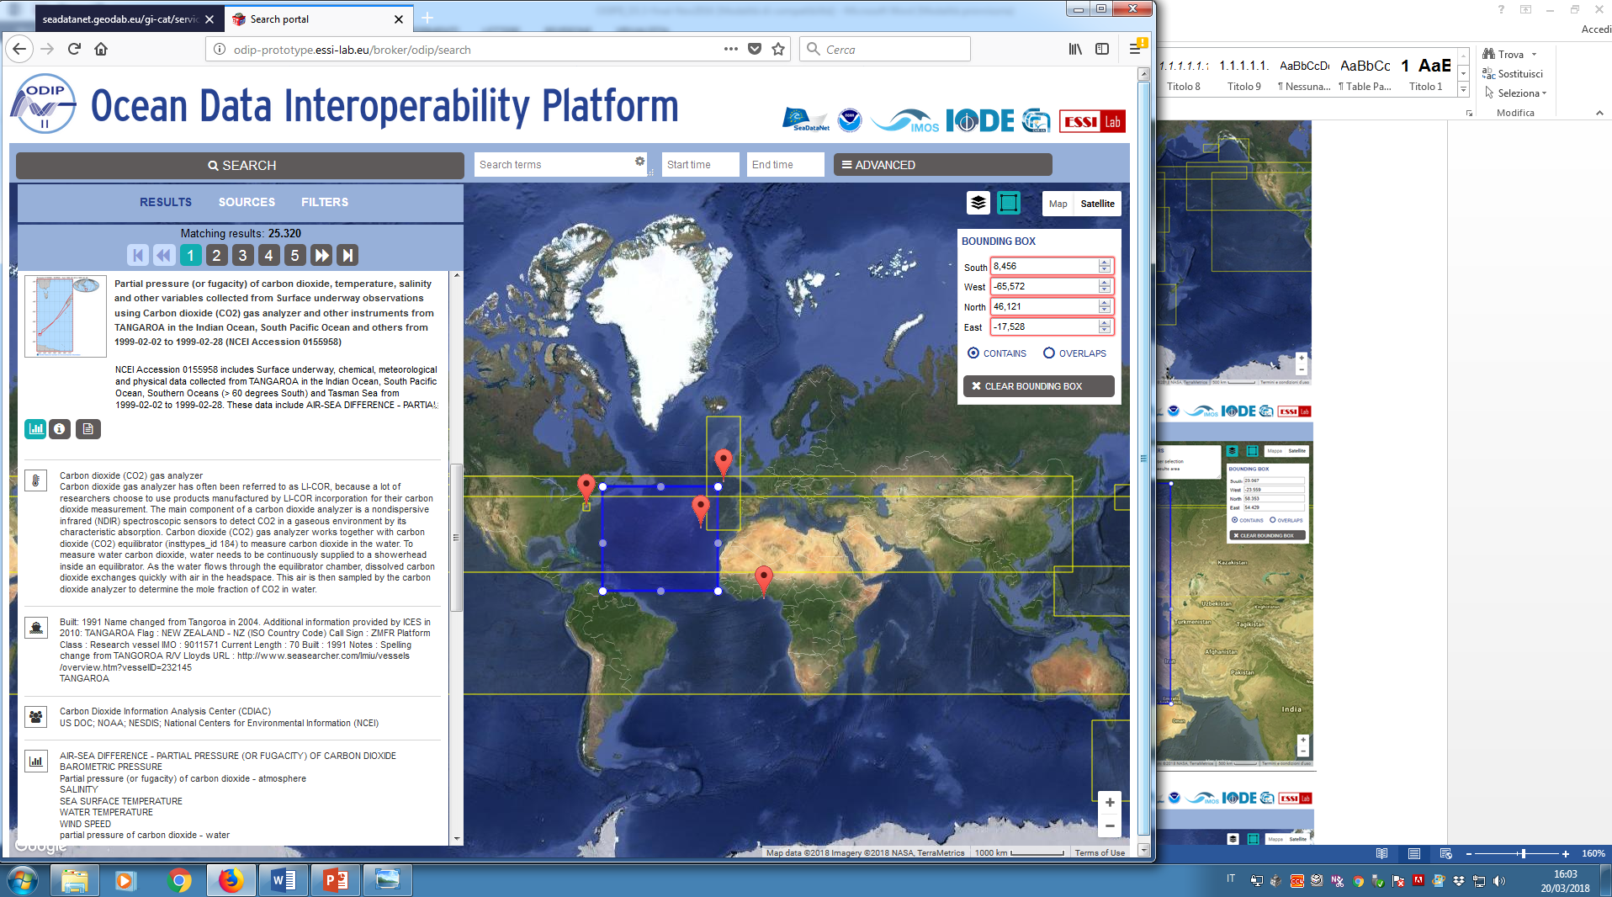 | Measuring instruments used to acquire the data.  E.g. BathyThermograph
Platform from which the data were taken.
E.g. ATLANTIC STAR
Organisation which created the resource.
E.g. NOAA
Attribute described by the measurement value.
E.g. water depth

ODIP target elements are usually documented with controlled vocabulary terms by the regional data providers (although in general they are coming from different vocabularies, depending on the provider). They can be shown clicking on the result measurement info icon for each record (see Figure 2.1.3).

Figure 2.1.3 ODIP test portal: the record overview on the left includes target ODIP elements, such as instruments, parameters, originators and platforms.
To further reduce the matching result set, in addition to search constraints, the ODIP test portal exercises the ODIP broker filter capability, similar to the functionality commonly made available by many e-commerce portals. Using this feature a list of values included in the result set for the main metadata elements is presented to the user, sorted by the number of occurrences for each value (see Figure2.1.4). By clicking on a specific value, an additional constraint is added to the present query constraints reducing the result set by selecting only the resources having the selected values documented.
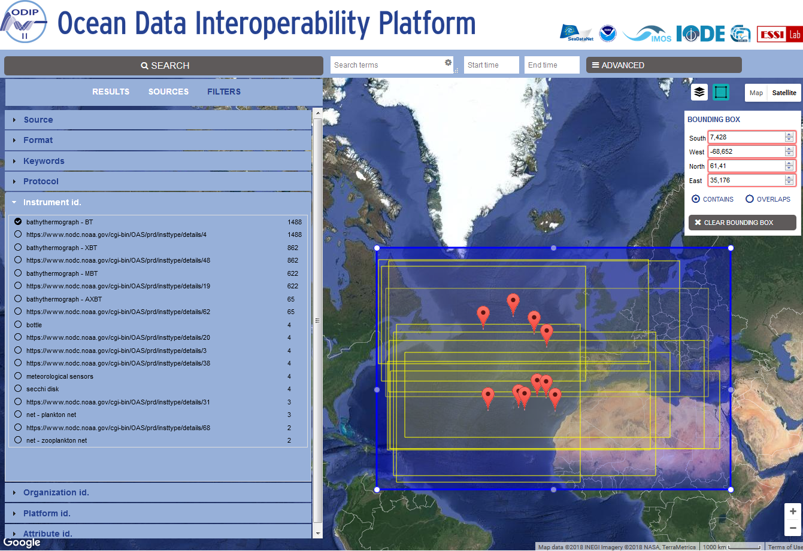
Figure2.1.4 ODIP test portal filter capability
Finally the ODIP test portal uses the ODIP broker to semantically augment discovery capabilities (by making underlying use of the Rosetta Stone component). Previously GEODAB has already developed a functionality for semantic discovery, utilizing textual terms expansion and navigation by leveraging common SPARQL endpoints and thesaurus (such as INSPIRE GEMET). This is documented in the publication "Methodologies for augmented discovery of geospatial resources", available at:
https://books.google.it/books?hl=en&lr=&id=-rOeBQAAQBAJ&oi=fnd&pg=PA305&ots=Jt7S8575W8&sig=7vYboPsrYQDHLBVpRpenIkNptqg#v=onepage&q&f=false
Building on top of this experience, the ODIP test portal has been designed to exercise the broker semantic capabilities (enabled by Rosetta Stone) through a user friendly interface (see Figure 2.1.5).
A semantic widget has been designed to exercise semantic queries, it can be reached clicking on the “Advanced” button on the top right part of the portal. The semantic widget presents a field for each ODIP target element to the user, in order to it make possible to constraint the query by one or more elements. By clicking on a given field (e.g. “parameter” field), three lists of terms coming from the three different regional providers are suggested: the user can choose a term from one of the three lists, to further constraint the query (e.g. “Sea level” from SeaDataNet vocabulary).

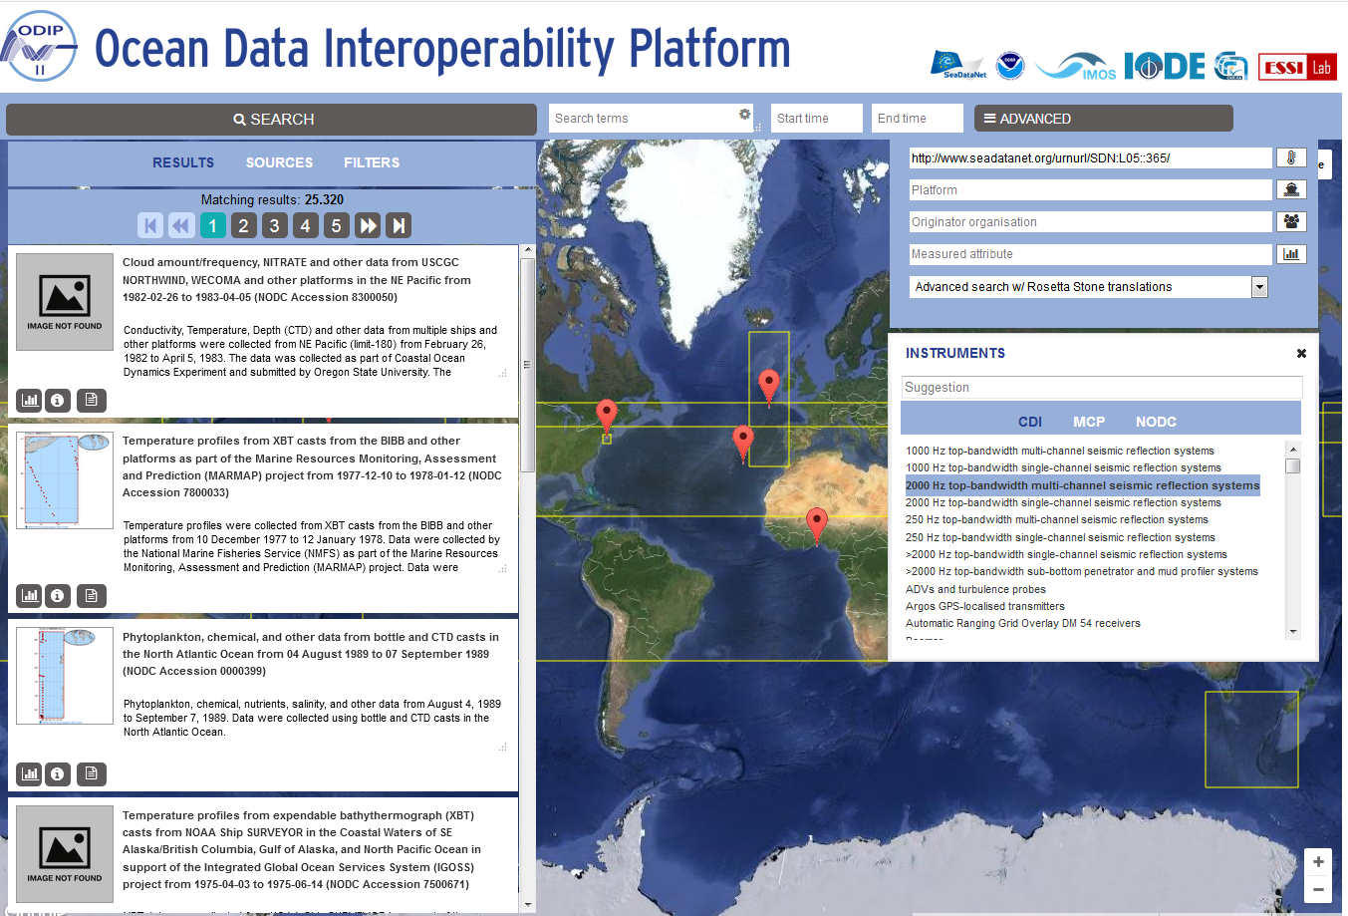
Figure 2.1.5 ODIP test portal semantic widget enables exercising Rosetta Stone augmented queries
The search can then be executed using one of four different modes:
- exact query: the simplest mode, it only matches records tagged with the selected value (in our example only “Sea level” records from SeaDataNet would be returned).
- Advanced search using Rosetta Stone translations: leveraging broker semantic capabilities, this mode matches:
  - records tagged with the selected value
PLUS
  - records tagged with translated terms (synonyms) coming from the other vocabularies
In the given example it returns:
- “Sea level” tagged records from SeaDataNet
PLUS
- “Sea level” tagged records from AODN
PLUS
- “Sea level” tagged records from NODC.
- Advanced search using Rosetta Stone narrow match: this search mode matches:
  - records tagged with the selected value
PLUS
  - records tagged with terms that are in a semantically narrower relation with respect to the search term
In the given example selecting as a search term for the instrument ODIP target the “Pressure sensor” value from the NODC vocabulary the result set includes:
  - “Pressure sensor” tagged records from NODC
PLUS
  - “Water pressure sensor” tagged records from SeaDataNet
- Advanced search using Rosetta Stone broad match: same concept as the narrow match, but with the opposite broader (more general) relation.
In the given example, selecting as a search term for the instrument ODIP target the “Water pressure sensor” value from the SeaDataNet vocabulary the result set includes:
  - “Water pressure sensor” tagged records from SeaDataNet
PLUS
  - “Pressure sensor” tagged records from NODC

Establishing horizontal interoperability by developing an ODIP interface using WMS – WFS

Originally it was planned to develop and publish also a Discovery and Access service at the ODIP portal, using WMS-WFS protocol. SeaDataNet and AODN both have operational WMS-WFS services. However NCEI has not (yet) implemented WMS and WFS services; in many cases there is a link to a static image included which gives a detailed map of the observations at granule level.

The ODIP test portal includes options to display on a map the position of the collections from the three sources, and links in the metadata to display the granules at the individual portals, which in case of NCEI concerns displaying the static images.

However it has not been possible to expand the ODIP test portal with the earlier targeted WMS – WFS search functionality, due to the missing of WMS-WFS at NCEI.

Conclusion:
It has been possible to expand the common output metadata format of the GEODAB Brokerage service with extra fields for platforms, parameters and instruments which facilitates harvesting more enriched metadata from the regional discovery services (SeaDataNet, NCEI and AODN) into the global GEOSS and ODP portals. In addition semantic brokerage has been added to the GEODAB metadata brokerage service by developing and integrating the Rosetta stone service. This is demonstrated by a dedicated ODIP test portal which interacts with the 3 regional discovery services (SeaDataNet, NCEI and AODN) and includes functionality for querying the 3 sources, using any of the regional supported vocabularies for platforms, parameters and instruments. The demonstrator has a limited set of mappings, however it is a matter of extending the mappings between the relevant vocabularies by the operators of the engaged regional services to achieve more coverage. It is aimed that the ODIP test pilot will be adopted and further elaborated in the SeaDataNet infrastructure as part of the SeaDataCloud activities for providing discovery and access to international data sources for SeaDataNet users. Unfortunately it has not been possible to expand the ODIP test portal with WMS – WFS search functionality for horizontal interoperability, due to the fact that the NCEI discovery service has no WMS-WFS (yet).

ODIP Prototype 2+

The ODIP Prototype 2+ concerns Cruise Summary Reporting from Europe (SeaDataNet), USA (R2R) and Australia (MNF) towards the global POGO portal. The ODIP Prototype 2+ has been led by BSH with contributions from partners from the three regions. Activities have been undertaken and/or are planned for each of the targets of the ODIP Prototype 2+ project:

- further population of the CSR directory by ODIP II regions;
- analysing the upgrading of the CSR metadata format, Schema and related tools and services following earlier R2R suggestions;
- publishing CSRs also in RDF by means of a SPARQL endpoint.

Further population of CSR directory

CSR Statistics
The following table gives the total CSR submission from all cruises (including non-POGO ships).
Partner country | Total submissions (including updates) | POGO
Europe | 44916 | 7840
USA | 3176 | 1776
Australia | 163 | 61
Table 2.2.1: CSR submissions

Partner country | Total submissions via ODIP II intermediation
Europe | N.A.
USA | 761
Australia | 54
Table 2.2.2: CSR submission via ODIP II

The USA CSR entries are populated by the Rolling Deck to Repository (R2R) team. In practice the R2R CSRs are dropped into a WAF as XMLs and downloaded by BSH. This works but in the future it is hoped that R2R will adopt the CSR harvesting procedure.
The Australian CSR entries concern the Aurora Australis RV cruises from 2014 till 2018. Moreover CSIRO will start with CSR entries from the “RV Investigator”. This is done by using the SeaDataNet MIKADO XML editor and providing BSH with CSR XML files.

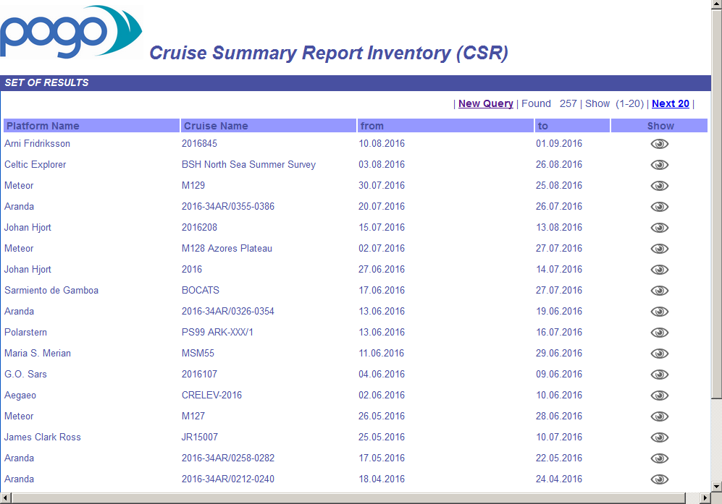
Figure 2.2.1: CSR published at the POGO portal
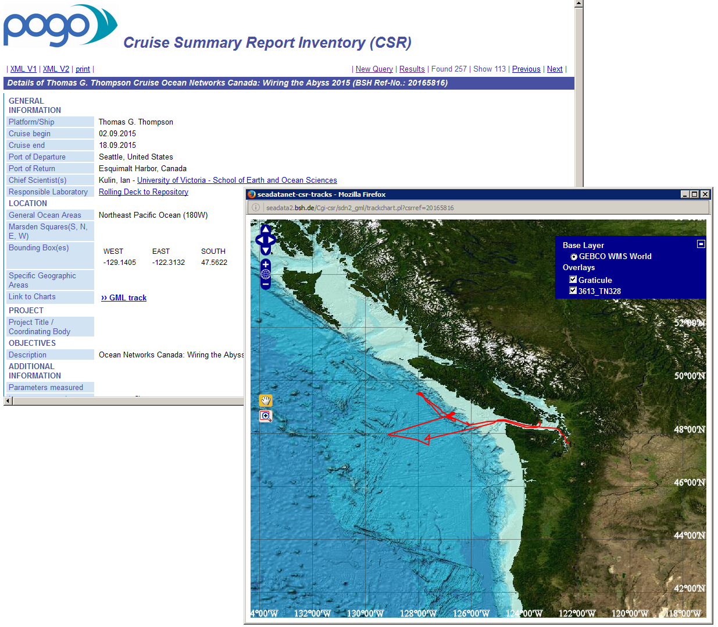
Figure 2.2.2: Example of dynamic cruise chart via WMS at the POGO portal
The CSR Schema which supports tracks in GML enables WMS services offering detailed information on the navigational tracks. An example from an R2R cruise is shown above.

CSR harmonisation with ICES
A large number of the CSRs in the central inventory originated from the ICES ROSCOPs from 2004 and before. The contents of these legacy records could not be updated to the present standards by the SDN partners due to missing metadata. Among these records are a large number of cruises from Australia, Canada and the USA containing valuable information on earlier cruises.
In the last years ICES has started to partially adopt the SeaDataNet standards and vocabularies. BSH created a special CSR web service such that ICES can also have access to the SeaDataNet CSRs for the cruise metadata to their datasets. Since July 2015 the ICES cruise metadata are daily synchronized with the SeaDataNet central CSR inventory based on the “amendment date” of the record.
In the meantime ICES also has a CSR web service so that BSH can harvest the updated and upgraded ICES legacy as well as new CSR records. This allowed to harmonise from ICES to the CSR central inventory. All the Australian, Canadian and US CSRs (via the ICES web service) have been updated which BSH has in the CSR central inventory from ICES. Also most of the other legacy CSR records could be matched to the ICES CSR reference numbers so that in the future it should be no problem to update these records for the POGO and SeaDataNet portals. All these records now have ICES as collating centre and the ICES reference number as local CSR ID in the CSR database. All other records which could not be matched have been set the "deprecated" flag so that these do not appear on the CSR homepage anymore. Fisheries and Oceans Canada (Mathieu OUELLET) has worked closely with ICES to update all the Canadian CSRs.
Vocabularies
The primary vocabulary requirement for Prototype 2 has been the extension of the content of the SeaDataNet C17 platform vocabulary served by NVS to cover all vessels of interest to the US R2R project plus all cruises in the CSR database at BSH, including V0 records. Existing coverage of Australian research vessels was already adequate and complemented with entries for new vessels.
At the start of ODIP II there were nearly 3000 ship codes for American vessels in the ICES system for which the only identification metadata attribute was the name. Of these over 100 were identified that were research vessels in the broadest sense of the word, which included vessels associated with academic institutions, NOAA ships and naval hydrographic and oceanographic survey vessels. These were prioritised in a project covering all US vessels and have been added to C17 together with over 1000 American warships. There are still a few vessels missing from the BSH system, but these are the most difficult cases with either known issues or very little available information. This work has been significantly assisted through the development of tooling to automate the comparison of metadata held in ICES and BODC systems. This comprises a simple schema in the BODC Oracle system comprising two tables of identical structure. One is populated from C17 by a call to a PL/SQL procedure. The other is populated by a Java application that issues service calls to the ICES system. Once populated the two tables may easily be compared and contrasted using SQL. To date this system has been used to identify ICES codes missing from C17 and to generate reports of ICES codes that BODC recommend for deprecation in the ICES system, such as stations and ferry routes.

Mapping and publishing CSR as Linked Data in synergy with SeaDataCloud
Linked Data is a mechanism for publishing structured data on the World Wide Web, and using Web addresses to provide connections between data objects. Linked Data was proposed by Sir Tim Berners-Lee as a foundation of a “Web of Data”, in contrast to the traditional “Web of Documents” which is well known.
Linked Data has gained ground in the marine science data management community over recent years, with projects in the United States (such as Rolling Deck to Repository and the Biological and Chemical Oceanography Data management Office) publishing records as Linked Data. The SeaDataNet common vocabularies, as published on the NERC Vocabulary Server, have been utilised in these developments.
Linked Data representations allow ease of interoperability at a global scale. The ability to find relevant data is improved by making the linked data information accessible to search engines and making the linked data pages as human readable resources on the web. Search engines browse the internet and consume structured information held on webpages. By speaking the same language that the search engines use to structure the information harvested, it makes it easier for the search engine to apply context to the information collected. The main search engines use the schema.org ontology to describe webpages and where schema.org headings are used within the webpage text this in turn allows a webpage to be better indexed within search results.
The SeaDataNet infrastructure contains a number of metadata catalogue services which are regularly maintained by the network of NODCs. Following the discussions and insights gained in ODIP II on approach and benefits of the Linked Data concept for interoperability and discovery on the semantic web it was decided in SeaDataCloud to strive for applying and fully exploiting the opportunities of the Linked Data concept for the range of SeaDataNet catalogues.
Linked data can be published to the web using SPARQL endpoints. SPARQL is a W3C standard and the query language used to query Resource Data Framework (RDF) data. The name is pronounced "sparkle", which is a recursive acronym for SPARQL Protocol and RDF Query Language. By deploying SPARQL endpoints for each SeaDataNet catalogue the infrastructure will then be in place for other interested parties to not only harvest, reuse or link to the SeaDataNet catalogues but also to build user specific web services incorporating SeaDataNet metadata and data holdings.
The Cruise Summary Reports (CSR) catalogue is one of the SeaDataNet catalogue services and its mapping was undertaken by Marine Institute in cooperation with the USA R2R consortium, in particular with Bob Arko of the Lamont-Doherty Earth Observatory, Columbia University, in a synergy between the ODIP II and SeaDataCloud projects.
Linked Cruise Summary Reports:
Due to the highly specialised nature of the information included within a Cruise Summary report, there does not exist a standard vocabulary or ontology to map these data to. However, significant progress has been made in the description of a research vessel cruise by the US projects “Rolling Deck to Repository” and “GeoLink” and some of their outputs have been reused.
The following namespaces are used:
cruise Cruise Linked Data patterns http://linked.iode.org/cruise#
cruise-summary Cruise Summary Report Linked Data patterns http://linked.iode.org/cruise-summary#
dcterms Dublin Core metadata terms http://www.purl.org/dc/terms/
foaf Friend-of-a-Friend ontology http://xmlns.com/foaf/0.1/
geolink National Science Foundation EarthCube Geolink ontology http://schema.geolink.org/1.0/base/main#
gsp GeoSparql http://www.opengis.net/ont/geosparql#
locn W3C Location ontology http://www.w3.org/ns/locn#
org W3C Organization ontology http://www.w3.org/ns/org#
prov W3C Provenance ontology http://www.w3.org/ns/prov#
rdfs RDF Schema http://www.w3.org/2000/01/rdf-schema#
xsd XML Schema http://www.w3.org/2001/XMLSchema#

Assumptions:
In the Linked Data patterns presented below, the clear distinction has been made between the following two information objects:
- The Cruise Summary Report
- The Cruise
This permits compatibility with the Rolling Deck to Repository data model which describes a cruise as an activity, which a Cruise Summary Report clearly is not, and has a minimum base set of metadata for a cruise. This is illustrated in the diagram below, on the recommendation of Simon Cox the link between the Cruise Summary Report and the Cruise has been modelled using the primaryTopic predicate from the Friend-of-a-Friend ontology.
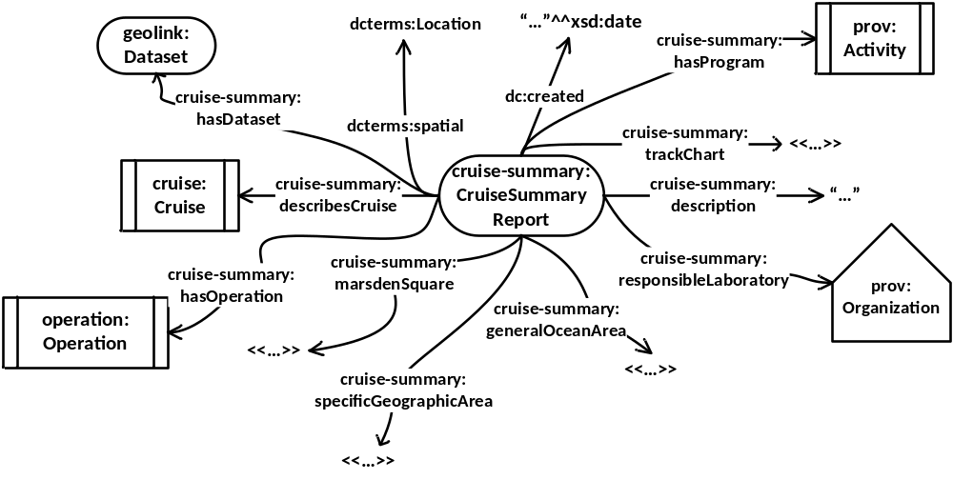
Figure 2.2.3. The Cruise Summary report Linked Data pattern
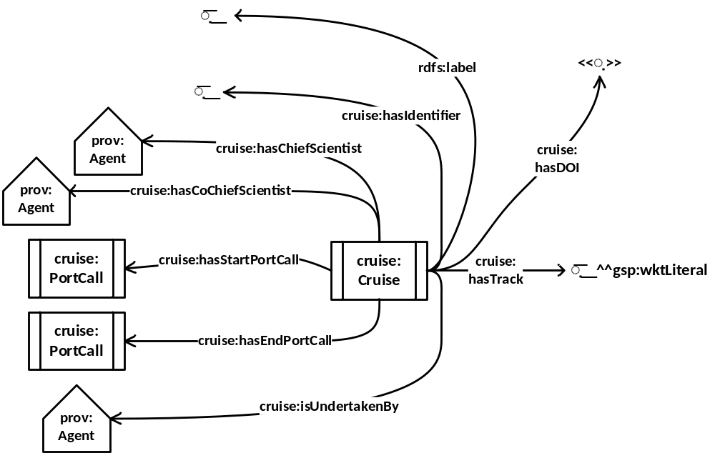
Figure 2.2.4. The Cruise Linked Data pattern taking elements required by the US Rolling Deck to Repository programme as a basis
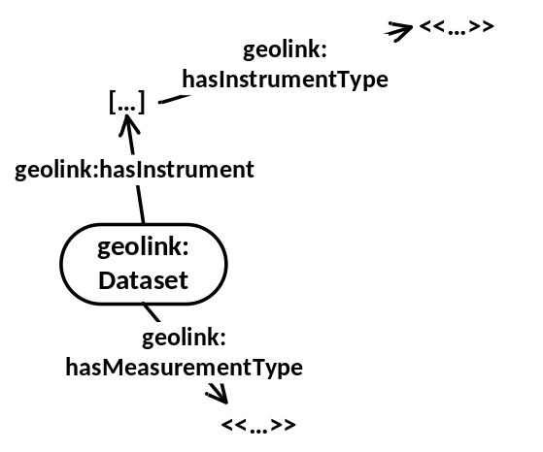
Figure 2.2.5. The Dataset pattern is used to connect a Cruise Summary Report to the measurement types and instruments used on a Cruise.

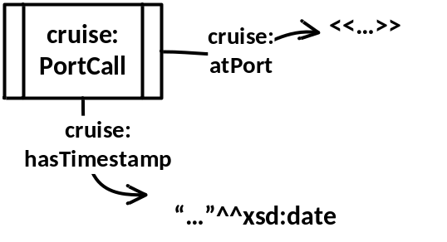
Figure 2.2.6. The Linked Data pattern used to describe the departure from a port at the strat of a Cruise; or the arrival at a port at the end of a Cruise

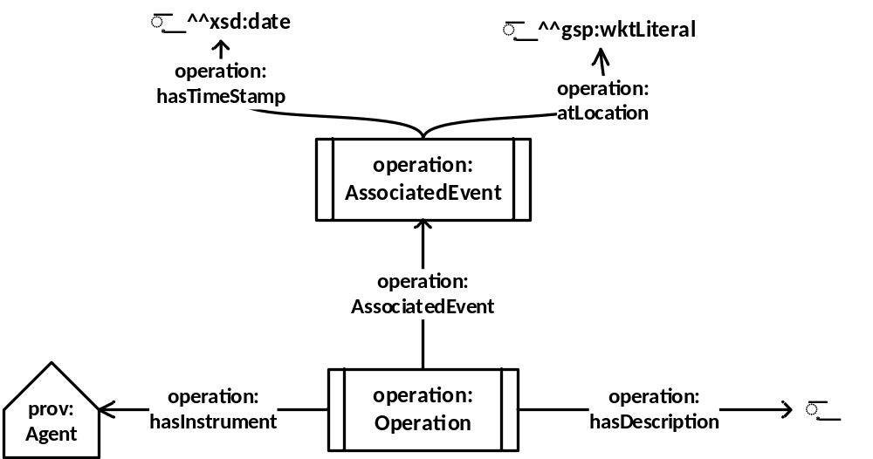
Figure 2.2.7. The pattern used to link a Cruise Summary Report to associated events on the Cruise
Prerequisites:
The following Linked Data terms are required to be published online.
@prefix cruise: <http://linked.iode.org/cruise#>.
@prefix dcterms: <http://www.purl.org/dc/terms/>.
@prefix geolink: <http://schema.geolink.org/1.0/base/main#>.
@prefix gsp: <http://www.opengis.net/ont/geosparql#>.
@prefix prov: <http://www.w3.org/ns/prov#>.
@prefix rdf: <http://www.w3.org/1999/02/22-rdf-syntax-ns#>.
@prefix rdfs: <http://www.w3.org/2000/01/rdf-schema#>.
@prefix xsd: <http://www.w3.org/2001/XMLSchema#>.
cruise:Cruise rdfs:subClassOf prov:Activity;
rdfs:label "Cruise"@en;
rdfs:comment "An event occuring on a Vessel traversing a Trajectory from one Port Call to another Port Call."@en.
cruise:PortCall rdfs:subClassOf prov:InstantaneousEvent;
rdfs:label "PortCall"@en;
rdfs:comment "A designated, specific port visited by a Vessel for some significant reason - the start or end of a mission; transfer of passengers, goods, or equipment."@en.
cruise:atPort rdfs:subPropertyOf prov:atLocation;
rdfs:domain cruise:PortCall;
rdfs:range xsd:anyUri;
rdfs:label "atPort"@en.
cruise:hasChiefScientist rdfs:subPropertyOf prov:wasAssociatedWith;
rdfs:domain cruise:Cruise;
rdfs:range prov:Agent;
rdfs:label "hasChiefScientist";
rdfs:comment "The prov:Agent at the range of this predicate should represent the chief scientist undertaking the research cruise"@en.
cruise:hasCoChiefScientist rdfs:subPropertyOf prov:wasAssociatedWith;
rdfs:domain cruise:Cruise;
rdfs:range prov:Agent;
rdfs:label "hasCoChiefScientist"@en;
rdfs:comment "The prov:Agent at the range of this predicate should represent one of a number of co-chief scientists undertaking the research cruise"@en.
cruise:hasDOI rdfs:subPropertyOf dcterms:identifier;
rdfs:label "hasDOI"@en;
rdfs:comment "Links a cruise to a persistent identifier assigned to it (such as a doi).";
rdfs:range cruise:Cruise;
rdfs:domain rdfs:Literal, xsd:anyURI.
cruise:hasEndPortCall rdfs:subPropertyOf prov:qualifiedEnd;
rdfs:range cruise:Cruise;
rdfs:domain cruise:PortCall;
rdfs:label "hasEndPortCall"@en.
cruise:hasIdentifier rdfs:subPropertyOf rdfs:label;
rdfs:domain cruise:Cruise;
rdfs:range rdfs:Literal;
rdfs:label "identifier"@en;
rdfs:comment "An identifier given to the research cruise by the organisation reposnible for the research cruise taking place."@en.
cruise:hasStartPortCall rdfs:subPropertyOf prov:qualifiedStart;
rdfs:range cruise:Cruise;
rdfs:domain cruise:PortCall;
rdfs:label "hasStartPortCall"@en.
cruise:hasTimeStamp rdfs:subPropertyOf prov:atTime;
rdfs:domain cruise:PortCall;
rdfs:range xsd:date, xsd:dateTime;
rdfs:label "hasTimeStamp"@en.
cruise:hasTrack a rdf:Property;
rdfs:domain cruise:Cruise;
rdfs:range gsp:wktLiteral;
rdfs:label "hasTrack"@en.
cruise:isUndertakenBy rdfs:subPropertyOf prov:wasAssociatedWith;
rdfs:domain cruise:Cruise;
rdfs:range prov:Agent;
rdfs:label "isUndertakenBy"@en;
rdfs:comment "The prov:Agent at the range of this predicate should represent the vessel undertaking the research cruise"@en.
cruise:undertook owl:inverseOf prov:wasAssociatedWith;
rdfs:domain prov:Agent;
rdfs:range cruise:Cruise;
rdfs:label "undertook";
rdfs:comment "The prov:Agent at the domain of this predicate should represent the vessel undertaking the research cruise"@en.
@prefix cruise: <http://linked.iode.org/cruise#>.
@prefix cruise-summary: <http://linked.iode.org/cruise-summary#>.
@prefix dbo: <http://dbpedia.org/ontology/>.
@prefix foaf: <http://xmlns.com/foaf/0.1/>.
@prefix geolink: <http://schema.geolink.org/1.0/base/main#>.
@prefix operation: <http://linked.iode.org/operation#>.
@prefix org: <https://www.w3.org/TR/vocab-org/>.
@prefix prov: <http://www.w3.org/ns/prov#>.
@prefix rdf: <http://www.w3.org/1999/02/22-rdf-syntax-ns#>.
@prefix rdfs: <http://www.w3.org/2000/01/rdf-schema#>.
@prefix xsd: <http://www.w3.org/2001/XMLSchema#>.
cruise-summary:CruiseSummaryReport rdfs:subClassOf prov:Entity, foaf:Document, geolink:Document;
rdfs:label "Cruise Summary Report"@en.
cruise-summary:additionalDocumentation rdfs:subPropertyOf rdfs:seeAlso;
rdfs:domain cruise-summary:CruiseSummaryReport;
rdfs:range xsd:anyURI;
rdfs:label "additionalDocumentation"@en.
cruise-summary:describesCruise rdfs:subPropertyOf foaf:primaryTopic;
rdfs:domain cruise-summary:CruiseSummaryReport;
rdfs:range cruise:Cruise;
rdfs:range xsd:anyURI;
rdfs:label "describesCruise"@en.
cruise-summary:description rdfs:subPropertyOf rdfs:comment;
rdfs:domain cruise-summary:CruiseSummaryReport;
rdfs:range rdfs:Literal;
rdfs:label "description"@en.
cruise-summary:generalOceanArea a rdf:Property;
rdfs:domain cruise-summary:CruiseSummaryReport;
rdfs:range xsd:anyURI;
rdfs:label "generalOceanArea"@en.
cruise-summary:hasOperation rdfs:subPropertyOf prov:wasGeneratedBy;
rdfs:domain cruise-summary:CruiseSummaryReport;
rdfs:range operation:Operation.
cruise-summary:hasProgram a rdf:Property;
rdfs:subPropertyOf prov:wasGeneratedBy;
rdfs:domain cruise-summary:CruiseSummaryReport;
rdfs:range prov:Activity, dbo:ResearchProject, geolink:Program;
rdfs:label "hasProgram".
cruise-summary:marsdenSquare a rdf:Property;
rdfs:domain cruise-summary:CruiseSummaryReport;
rdfs:range xsd:anyURI;
rdfs:label "marsdenSquare"@en.
cruise-summary:responsibleLaboratory rdfs:subPropertyOf prov:wasAttributedTo;
rdfs:domain cruise-summary:CruiseSummaryReport;
rdfs:range org:Organization, foaf:Organization, prov:Organization;
rdfs:label "responsibleLaboratory"@en.
cruise-summary:specificGeographicArea rdfs:subPropertyOf rdfs:comment;
rdfs:domain cruise-summary:CruiseSummaryReport;
rdfs:range rdfs:Literal;
rdfs:label "specificGeographicArea"@en.
cruise-summary:trackChart rdfs:subPropertyOf rdfs:seeAlso;
rdfs:domain cruise-summary:CruiseSummaryReport;
rdfs:range xsd:anyURI;
rdfs:label "trackChart"@en.
@prefix gsp: <http://www.opengis.net/ont/geosparql#>.
@prefix operation: <http://linked.iode.org/operation#>.
@prefix prov: <http://www.w3.org/ns/prov#>.
@prefix rdf: <http://www.w3.org/1999/02/22-rdf-syntax-ns#>.
@prefix rdfs: <http://www.w3.org/2000/01/rdf-schema#>.
@prefix xsd: <http://www.w3.org/2001/XMLSchema#>.
operation:Operation rdfs:subClassOf prov:Activity;
rdfs:label "Operation"@en;
rdfs:comment "An activity (such as a measurement or mooring) occuring on a research vessel cruise, flight, deployment, etc..."@en.
operation:AssociatedEvent rdfs:subClassOf prov:InstantaneousEvent;
rdfs:label "AssociatedEvent".
operation:Measurement rdfs:subClassOf operation:Operation;
rdfs:label "Measurement"@en.
operation:Mooring rdfs:subClassOf operation:Operation;
rdfs:label "Mooring"@en.
operation:atLocation rdfs:subPropertyOf prov:atLocation;
rdfs:label "atLocation"@en;
rdfs:domain operation:AssociatedEvent;
rdfs:range gsp:wktLiteral.
operation:associatedEvent a rdf:Property;
rdfs:label "associatedEvent"@en;
rdfs:domain operation:Operation;
rdfs:range operation:AssociatedEvent.
operation:description rdfs:subPropertyOf rdfs:comment;
rdfs:domain operation:Operation;
rdfs:range rdfs:Literal.
operation:hasTimeStamp rdfs:subPropertyOf prov:atTime;
rdfs:domain operation:AssociatedEvent;
rdfs:range xsd:date, xsd:dateTime;
rdfs:label "hasTimeStamp"@en.
operation:numberOfMeasurements a rdf:Property;
rdfs:domain operation:Measurement;
rdfs:range xsd:integer;
rdfs:label "numberOfMeasurements"@en.
Recommendations:
It is recommended that a non-SeaDataNet/SeaDataCloud namespace is used for the publication of the above Linked Data terms due to the global nature of the users. Initial discussions with the Ocean Knowledge Platform project of the International Oceanographic Data and Information Exchange have been positive, and these will be followed up. The name space http://linked.iode.org/cruise# has been used in the mapping but does not resolve to an ontology at time of writing.
Port entries in C38 should be given an RDF linkage to their countries.
Port entries in C38 should be made instances of geolink:Place and prov:Location.
Research vessels entries in C17 should be made instances of prov:Entity
CSR Mappings:
CSR fields | Linked Data mapping | Notes
csr_identifier | Cruise Summary Report > rdf:about | Use the SeaDataNet Global Identifier
collate_centre | Cruise Summary Report > sdn-ld:collate-centre | Links to an EDMO record
Metadata creation date | Cruise Summary Report > dcterms:created
Cruise ID | Cruise > rdfs:label
Responsible Laboratory | Cruise Summary Report > cruise-summary:responsibleLaboratory | Links to an EDMO record
Objectives | Cruise Summary Report > cruise-summary:description
Responsible Chief Scientists | Cruise > cruise:hasChiefScientist / cruise:hasCoChiefScientist | Use hasChiefScientist for one PI; hasCoChiefScientist for multiple PIs  Where scientist has an ORCID this should be used. Until all scientists’ have ORCIDs this cannot be made mandatory.
Track Chart | Cruise Summary Report > cruise-summary:trackChart
INSPIRE Theme | Cruise Summary Report > dcterms:subject | Always http://vocab.nerc.ac.uk/collection/P22/current/28/ for Ocean Geographic Feature
Port of Departure | Cruise > cruise:PortCall > cruise:atPort | Links to http://vocab.nerc.ac.uk/collection/C38/current/  When the country is mapped to the Port, the Country of Departure field will be inherited
Port of Return | Cruise > cruise:PortCall > cruise:atPort | Links to http://vocab.nerc.ac.uk/collection/C38/current/ When the country is mapped to the Port, the Country of Return field will be inherited
Ship | Cruise > cruise:isUndertakenBy | Links to http://vocab.nerc.ac.uk/collection/C17/current/ Platform Class is inherited
Project | Cruise Summary Report > cruise:hasProgram | Links to an EDMERP record
General Ocean Areas | Cruise Summary Report> cruise-summary:generalOceanArea | Links to http://vocab.nerc.ac.uk/collection/C19/current/
Geographic Coverage | Cruise Summary Report > cruise-summary:marsdenSquare | Links to http://vocab.nerc.ac.uk/collection/C37/current/
Parameters | Dataset > geolink:hasMeasurementType | Links to http://vocab.nerc.ac.uk/collection/L05/current/
Instruments | Dataset > geolink:hasInstrument | Links to http://vocab.nerc.ac.uk/collection/P02/current/
Main theme of the dataset | Cruise Summary Report > dcterms:subject | Always http://registry.it.csiro.au/def/isotc211/MD_TopicCategoryCode/oceans for oceans
Language | Cruise Summary Report > dcterms:language | Always http://id.loc.gov/vocabulary/iso639-1/en for English
Cruise Start Date | Cruise > cruise:PortCall > cruise:hasTimeStamp | Using xsd:date format
Cruise End Date | Cruise > cruise:PortCall > cruise:hasTimeStamp | Using xsd:date format
Specific Geographic Areas | Cruise Summary Report > cruise-summary:specificGeographicAreas
Bounding Box | Cruise Summary Report > dcterms:spatial | Using gsp:wktLiteral format to describe the bounding box
Additional Documentation | Cruise Summary Report > cruise-summary:additionalDocumentation
Mooring | Cruise Summary Report > cruise:hasOperation > operation:Mooring | operation:Mooring contains:  - operation:description  - operation:associatedEvent  - operation:hasTimeStamp  - operation:atLocation  - operation:instrument  - sdc:hasInstrumentID  - sdc:hasInstrumentType  - sdc:hasPlatformCode  - sdc:hasPlatformDescription  - sdc:hasResponsiblePerson
Measurement | Cruise Summary Report > cruise:hasOperation > operation:Measurement | operation:Measurement contains:  - operation:description  - operation:associatedEvent  - operation:hasTimeStamp  - operation:atLocation  - operation:instrument  - sdc:hasInstrumentID  - sdc:hasInstrumentType  - sdc:hasPlatformCode  - sdc:hasPlatformDescription  - sdc:hasResponsiblePerson  - sdc:operationNumberOfMeasurements  - sdc:operationUnitsOfMeasure
Example in Turtle (TTL)
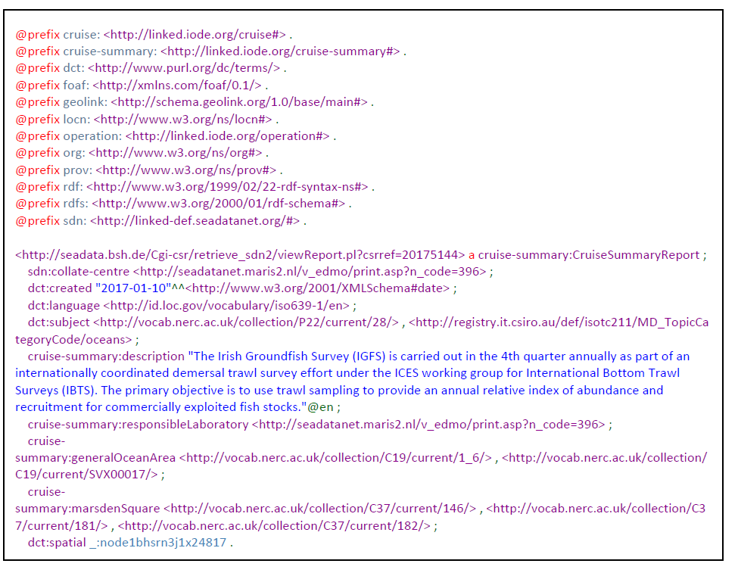

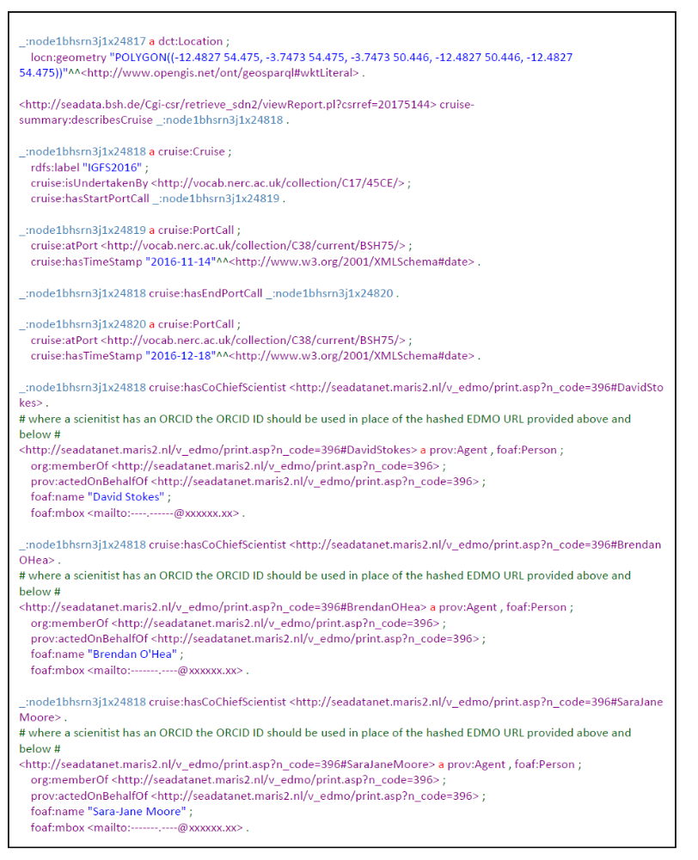
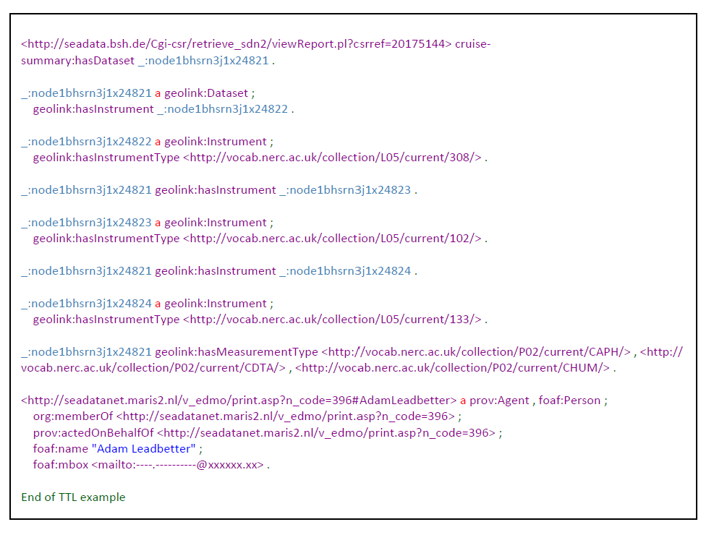
The following example is designed to show the pattern of Moorings and Measurements.
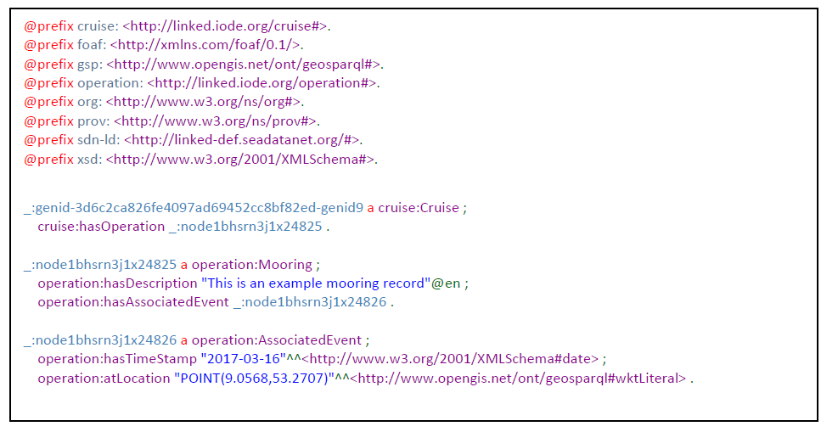
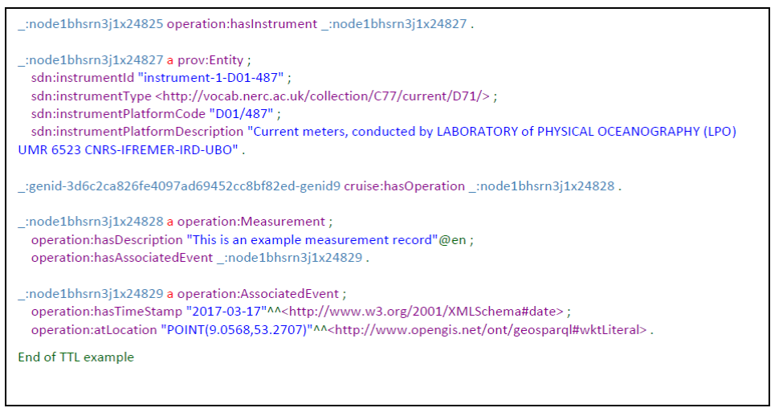

RDF/XML examples of CSR are given in Appendix B.
Implementing the CSR SPARQL endpoint:
Above a pattern has been laid out for publishing the CSR metadata as Linked Data and an examples has been given. The next step will be dedicated to implementing a so-called SPARQL (RDF) endpoints for the CSR directory. This will be undertaken by BSH in the framework of the SeaDataCloud project and by adopting the approach as already undertaken by BODC for the SeaDataNet EDMED and EDIOS catalogues and MARIS for the SeaDataNet EDMO catalogue.
The catalogues are to be published as Resource Description Framework (RDF) representations. RDF is the encoding language of Linked Data and the Semantic web, and has an associated query language (SPARQL) which allows interrogation of RDF graphs. Once the exemplar data have been published as RDF, they can be harvested into SPARQL endpoints which can be queried for, for example, information automated product building applications.
Both EDMED and EDIOS are managed within BODC in an ORACLE RDBMS. BODC developers have written an in-house java programme using the Jena Core library of the Jena ecosystem, which provides high-level functions for managing RDF data and “triplestores” (known as TDBs in the JENA vocabulary). A triplestore or RDF store is a database for storing and retrieving “triples” through semantic queries. A triple is a data entity composed of subject-predicate-object, like “Bob knows Fred”. The BODC programmes manage the following tasks:
- Retrieve the catalogue data from the underlying Oracle RDBMS
- Map the data to the relevant ontological elements
- Include relevant catalogue-level properties & resources
- Check the integrity of the returned data to be included in the triplestores
- Build the triplestores
This process happens nightly, using a linux cron job, ensure that new catalogue records are included in a timely fashion.
BODC has taken care to use best practices in software development:
- Software configuration is managed using standards-based file types (yaml)
- The ontological properties and resources are stored in XML
- Retrieval of the underlying catalogue data uses pl/sql functions
These best practices ensure that the triplestores can be easily added to with no changes & recompilation of the code base, and that there is suitable separation of logic between the different tasks of the workflow.
The triplestores are published by BODC on a Tomcat server using the Fuseki element of the JENA ecosystem. This makes the triplestores available using a SPARQL endpoint via HTTP. Installation and configuration of fuseki is straightforward. The SPARQL endpoint will return data as CSV, JSON, and XML (with multiple choices of XSLT transformations).
They are designed to be used as an API or machine-to-machine service, rather than an interactive web interface.
The figure below summarizes how the EDMED and EDIOS database are transformed by BODC from the ORACLE RDBMS into operational SPARQL endpoints and which software tools have been applied.

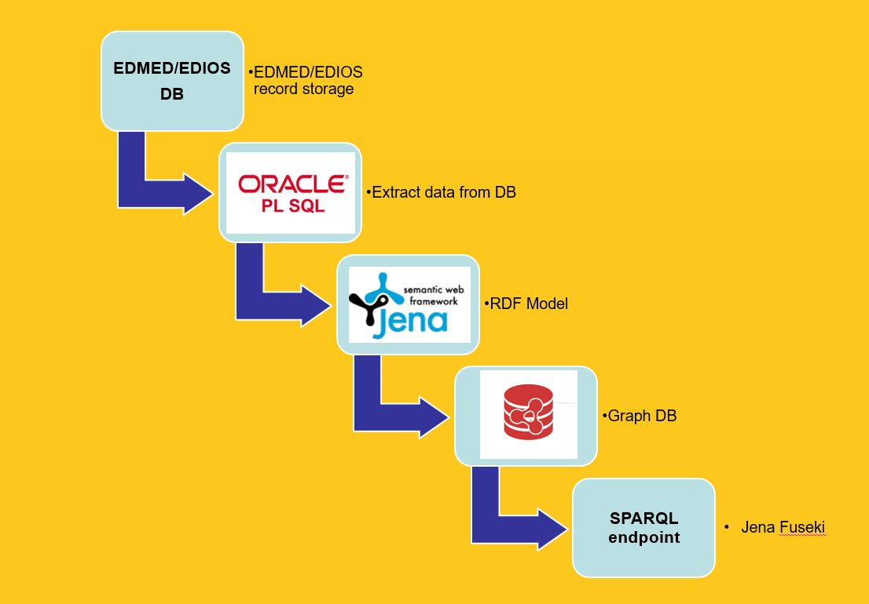
Figure 2.2.8: Workflow by BODC for EDMED and EDIOS
The associated URLs for EDMED and EDIOS are:
URL | Page
http://edmed.seadatanet.org/sparql/ | EDMED SPARQL endpoint web interface
http://edmed.seadatanet.org/sparql/sparql/ | EDMED SPARQL endpoint machine interface
http://edmed.seadatanet.org/ | EDMED landing page
http://edmed.seadatanet.org/search/ | EDMED Main Search page
http://edios.seadatanet.org/sparql/ | EDIOS SPARQL endpoint web interface
http://edios.seadatanet.org/sparql/sparql/ | EDIOS SPARQL endpoint machine interface

The SPARQL endpoints can be used by developers and they return data in a number of standard formats over HTTP
- Standard libraries can be used to interact with the responses
- Third party applications / apis can be built on top of any public triplestore
- SPARQL queries can be federated: link multiple triplestores with a single query
  - Increases value of data returned in a single query
  - Prevents data replication
Below some programming examples are given:

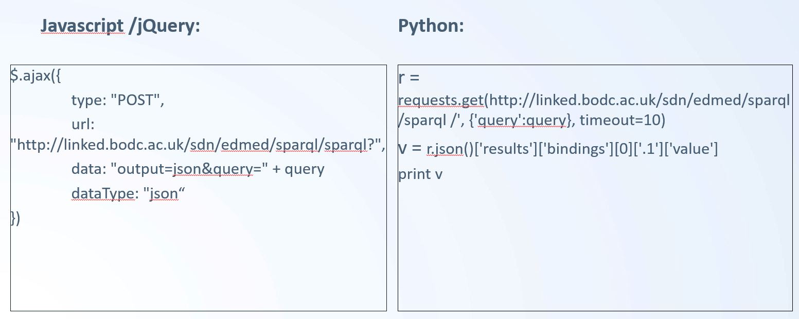
The implementation for EDMED, EDIOS and EDMO SPARQL endpoints is completed and operational. For CSR a comparable approach will be followed by BSH. The latter will make use of the experience of BODC and MARIS in order to have a swift implementation of CSR.
The associated URLs and Pages for CSR will be:
URL | Page
http://csr.seadatanet.org/sparql/ | CSR SPARQL endpoint web interface
http://csr.seadatanet.org/sparql/sparql/ | CSR SPARQL endpoint machine interface
http://csr.seadatanet.org/ | CSR landing page
http://csr.seadatanet.org/search/ | CSR Main Search page

ODIP Prototype 3+

The ODIP Prototype 3+ continued the earlier activities as undertaken for the ODIP Prototype 3. It focused on further improving the application of OGC Sensor Web Enablement (SWE) standards and services in concertation with many on-going regional projects. It has been built upon the earlier results to explore further enhancements and new technological approaches. Thereby also great attention was given to establishing synergy and tuning between the ongoing regional projects. The ODIP 3+ Prototype was led by 52°North with contributions from partners from the three regions. Activities have been undertaken for each of the targets of the ODIP Prototype 3+ project:

2.3.1 Evaluation of Sensor Web Technologies for Marine Applications
The aim of this sub-task was to evaluate different Sensor Web technologies, including the OGC Sensor Web Enablement (SWE) standards for facilitating the interoperable sharing of oceanographic observation data and metadata. Several activities have taken place.
SWE Technologies:
One important SWE component that was contributed to the ODIP Prototype 3+ was the Sensor Web viewer Helgoland which was originally developed in projects such as NeXOS, FixO³ and COLABIS. During the second half of the ODIP II project, especially the following functionalities were added to the Helgoland Sensor Web viewer in cooperation with the projects NeXOS, FixO³ and COLABIS:
- Support of new data types such as
  - Profile Observations
- Better representation mobile and stationary platforms
- Visualisation of multiple observed properties for a single trajectory
- Profiles along trajectories
In addition the software architecture as improved to facilitate the integration of new functionality and the customisation of the user interface design to the needs of different organisations.
The Helgoland Sensor Web viewer has been published as open source software by the ODIP II partner 52°North: https://github.com/52North/helgoland. This allows the flexible re-use of the software by organisations and projects.
In addition, the Helgoland Sensor Web viewer was provided by ODIP II for the use in other projects, such as the EMODnet Data Ingestion portal which used the Helgoland Sensor Web viewer for setting up a SWE Demonstrator (through the ODIP II partner BODC).
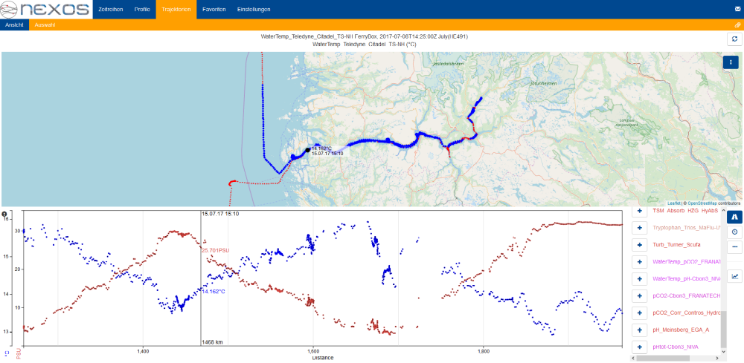
Figure 2.3.6: Trajectory View allowing the selection of multiple observed properties (Salinity and Temperature measured by RV Heincke in July 2017

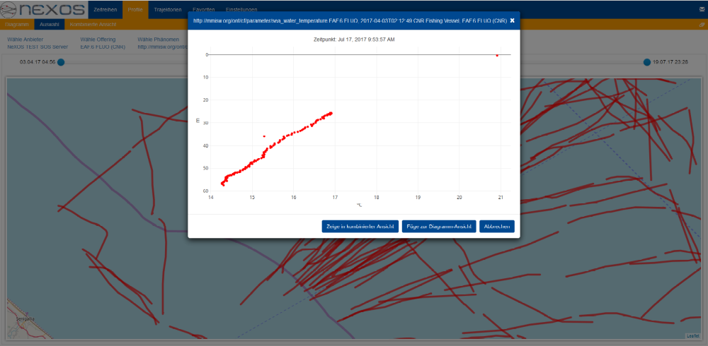
Figure 2.3.7: Preview of a Profile Observation

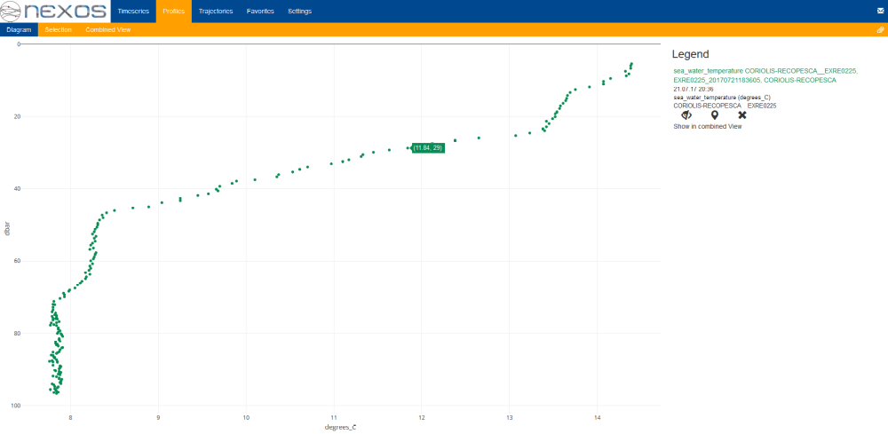
Figure 2.3.8: Profile Observation (Sea Water Temperature in different depths (consumed from Oceanotron)
Another development that is related to ODIP II Prototype 3+ is the SWE Ingestion Service developed as part of the SeaDataCloud project. The aim of this component is to facilitate the publication of marine observation data in research data infrastructures such as the SeaDataNet Common Data Index (CDI).
This service makes on the one hand use of the marine SWE profiles developed as part of ODIP II and is re-using certain components, which were also demonstrated in the Prototype 3. This comprises especially the 52°North SOS server and the smle SensorML editor.
In summary, this development comprises two components. The first one is an online service to describe observatories (or networks of observatories) so that the resulting descriptions will be encoded as SensorML metadata documents. Based on such descriptions, the ingestion service shall be enabled to automatically process and handle incoming observation data streams.
The second component is the Ingestion service itself, which is capable of receiving, decoding, and checking incoming real-time data streams (operated under the supervision of the PIs of the corresponding observatories). It makes use of the previously created SensorML-based descriptions of sensors and data streams in order to store the received data in a database. This component will make use of the 52°North SOS server in conjunction with further frameworks enabling the data ingestion workflow (i.e. Spring Cloud Data Flow).
To build the SWE Ingestion Service, especially the following research questions need to be answered:
- How to describe data streams? How can the structure of incoming data streams be described by SensorML documents so that they can automatically be interpreted?
- How to retrieve an input data stream from a platform? Many sensors do not push their data but require an active polling instead. To enable an automatic configuration of such pull-data flows, it is necessary to describe the commands and parameters of sensor interfaces.
To solve these questions, the SeaDataCloud project is able to rely on achievements of ODIP II regarding the development of SensorML 2.0 profiles for the marine community. This is complemented by the activities of BODC on the NERC Vocabulary Server which also ensures semantic interoperability of SensorML documents.

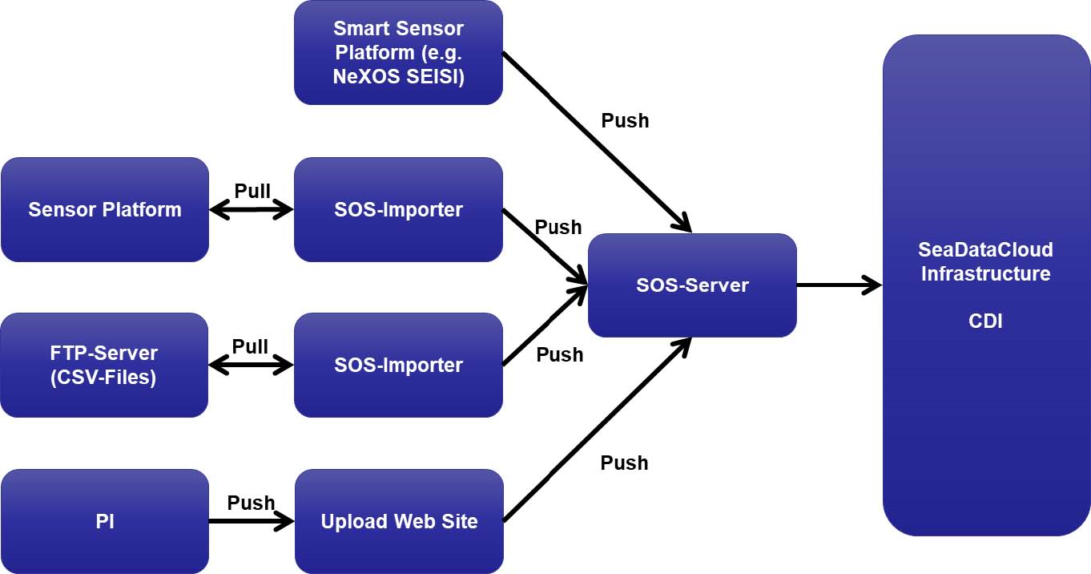
Figure 2.3.9: SeaDataCloud SWE Ingestion Architecture

Furthermore, several partners of the ODIP II consortium contributed SWE developments and deployments to the ODIP II Prototype 3+.
At AWI, two different aspects were covered. The first one concerns the metadata management for sensor platforms, devices and sensors. For this purpose, AWI has developed a corresponding Web Client based on technologies such as MySQL, Swagger (for API definition), and Elasticsearch. This service provides functionality for editing sensor metadata but also to export such metadata as SensorML 2.0 and JSON files.

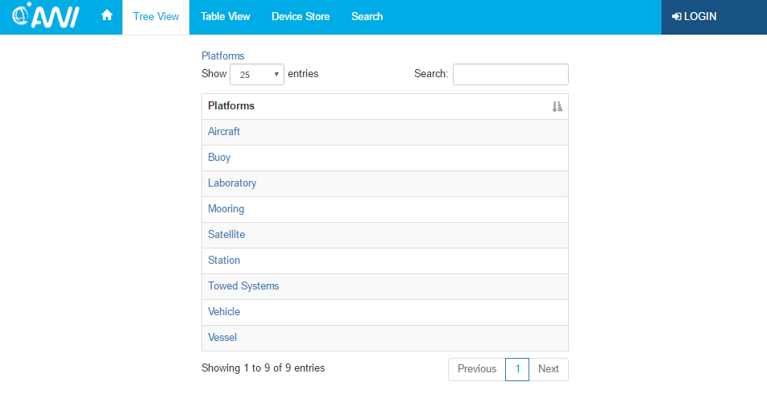
Figure 2.3.10: Screenshot of the Metadata Tool

This was complemented by the setup of a SOS server for data access (based on the 52°North SOS server) and a corresponding data viewer (based on 52°North Helgoland).
To enable the integration into the AWI infrastructure, it was necessary to develop a custom data access backend. As shown in Figure 2.3.11, the SOS server connects to two different data sources:
- The server sensor.awi.de for accessing the metadata about sensors and platforms
- A dedicated database which provides access to the actual observation data
From these data sources, the SOS server maintains its internal cache that allows efficient responses to incoming SOS requests. The supported operations comprise:
- GetCapabilities
- DescribeSensor
- GetObservation
- GetFeatureOfInterest
- GetDataAvailability
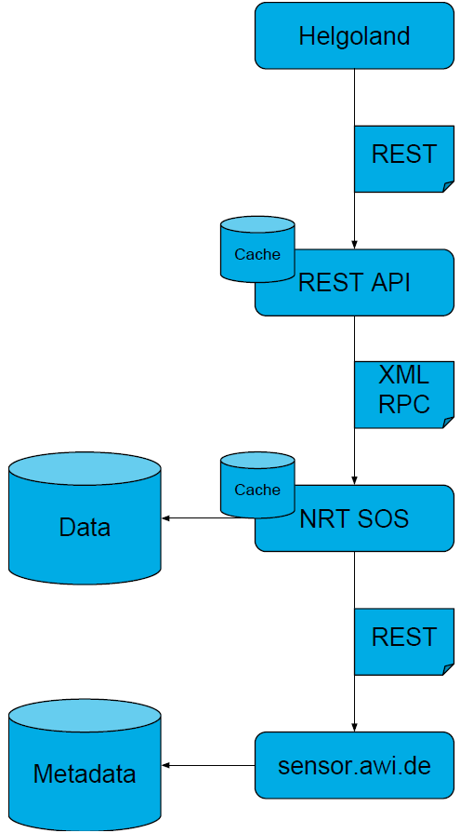
Figure 2.3.11: Overview of the Architecture Deployed at AWI
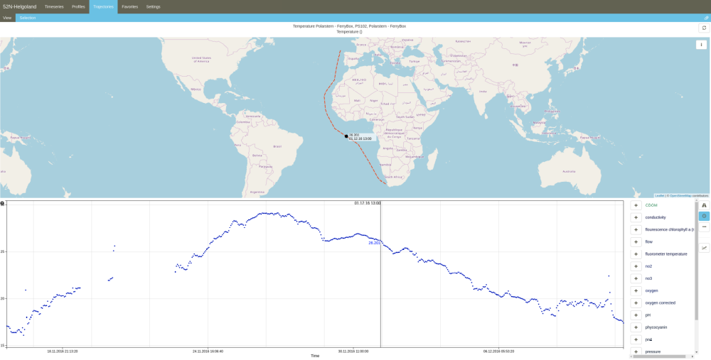
Figure 2.3.12: Data of the RV Polarstern visualised in the Helgoland Sensor Web Viewer
Complementary to the pull-based data access workflows based on the OGC SOS standard, the Prototype 3 also investigated push-based flows of observation data in conjunction with event processing functionality. For this purpose, the ODIP II partners 52°North and Esri cooperated on a demonstrator based on the ArcGIS the ArcGIS GeoEvent Server.
As part of this activity the ArcGIS GeoEvent Server was extended so that is can query the latest available observation data from OGC SOS servers. Subsequently, this pull-based data flow is converted to a push-based flow by pushing the gathered observation data into a processing and filtering pipeline which detects for example data that exceeds certain thresholds.
The resulting output (e.g. detected events) is subsequently pushed to different endpoints for further analysis or visualisation (e.g. Feature-Service, Stream-Service).
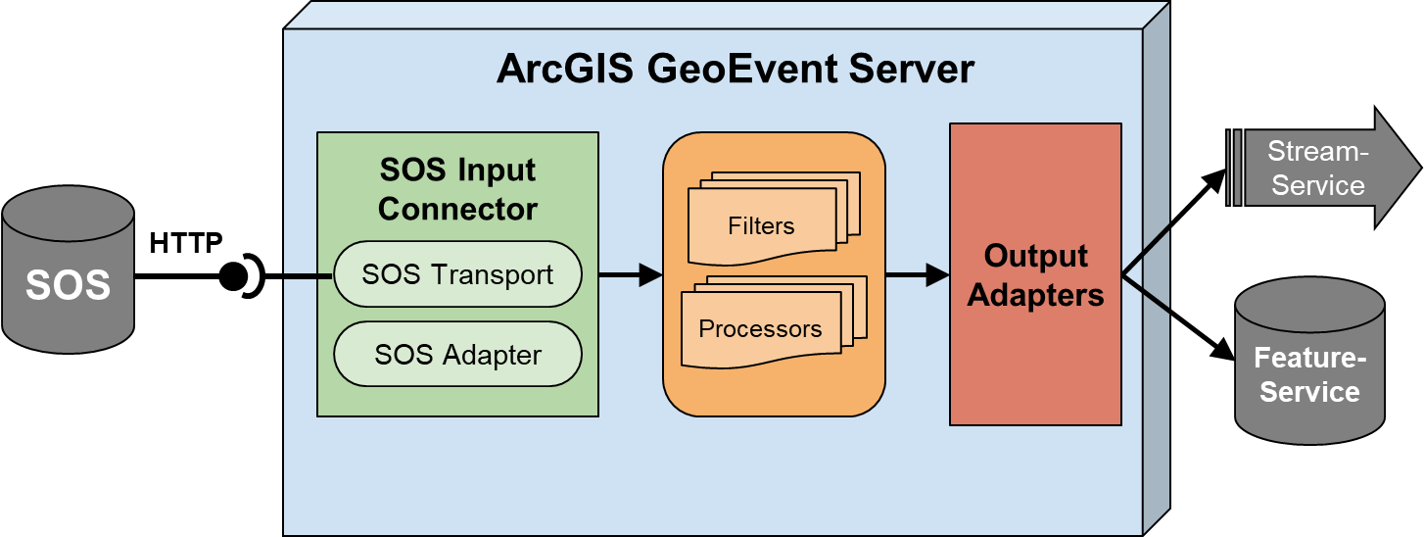
Figure 2.3.13: Overview of the Event Processing Workflow

Marine Sensor Web Profiles:
The broad range of activities using SWE standards for marine observation data and systems leads to a risk of incompatible approaches how the SWE specifications are applied. The OGC SWE standards were intentionally designed in a domain independent manner so that they can be applied in as many scenarios as possible. This idea goes hand in hand with a high level of flexibility within the specifications so that the same goals could be achieved in different ways.
To avoid interoperability issues, a common approach is needed how SWE specifications shall be applied for marine data and sensors. Furthermore, this should be complemented by a use of vocabularies (see below) to ensure not only common syntax but also common semantics.
Consequently ODIP II has continued this activity during the second half of the project with partners from several projects and initiatives: AODN, BRIDGES, envri+, EUROFLEETS/EUROFLEETS2, FixO3, FRAM, IOOS, Jerico/Jerico-Next, NeXOS, RITMARE, SeaDataCloud, SeaDataNet, SenseOcean, and X-DOMES.
Main questions that were treated during ODIP II comprise:
- How to provide metadata about sensing devices and platforms through the OGC SensorML 2.0 standard? This has resulted in a first profile of the OGC SensorML 2.0 standard for describing sensor/platform types as well as instances. A special challenge in the application of SensorML 2.0 was its soft-typing approach which usually results in a series of key-value-pairs describing the properties of a sensor or a platform. Consequently, the usage of controlled vocabularies for defining the different properties is of high importance to ensure semantic interoperability.
- How to encode and model observation data based on the ISO/OGC Observations and Measurements 2.0 (O&M 2.0) standard? For this aspect, special consideration was given to the new document “D2.9 Guidelines for the use of Observations & Measurements and Sensor Web Enablement-related standards in INSPIRE”. This document defines a set of common observation types, which also fulfil the requirements of marine applications.
- How to allow users the download of observation data sets? For this purpose the OGC Sensor Observation Service 2.0 (SOS 2.0) is used. In order to ensure also an alignment to other European recommendations, the INSPIRE Technical Guidance on the use of the SOS as an INSPIRE Download Service should be considered.
For organising and documenting the work on the marine SWE profiles several tools were used. This comprises:
- A mailing list with ca. 100 subscribers
- A Wiki is available for collecting examples of SWE usage
- A GitHub repository for collaboratively documenting the discussed profiles: (https://odip.github.io/MarineProfilesForSWE/).
- The vocabulary server of NERC/BODC that was extended to cover SWE terms
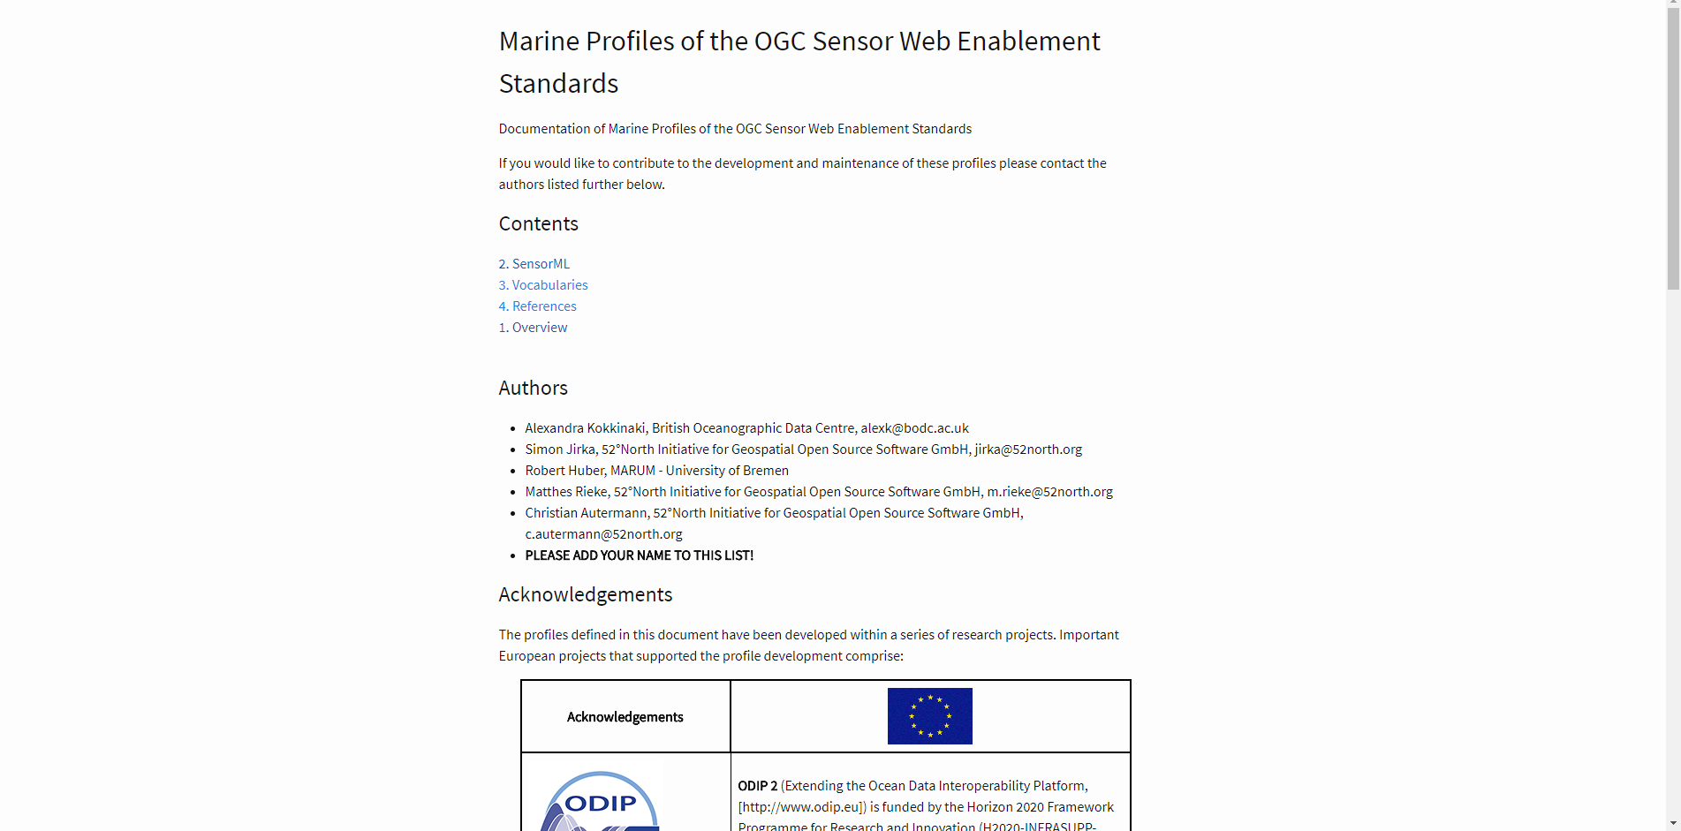
Figure 2.3.14: Frontpage of the ODIP Github-based Marine SWE Profiles Documentation

Analysing the handling of large volumes of data within SWE-based infrastructures

For the handling of large volumes of data within SWE-based infrastructure three main building blocks were identified:

- How can big heterogeneous spatio-temporal datasets be organized, managed and provided to Sensor Web applications?
- How can views on big data sets and derived information products be made accessible in the Sensor Web?
- How can big observation data sets be processed efficiently?

To answer these questions, the current state of Sensor Web technologies and requirements of users were analysed to identify shortcomings in the current technology stack. A special emphasis was put on the efficient retrieval of observational datasets and derived products with the conceptualization of a query language to enable a server-side (in particular cloud-based) processing of large observational data collections, which should extend the existing SOS interface.

To evaluate this, an elaborate use case was conceived that consists of the ground-truthing and potential improvement of sea surface temperature data recorded by earth observation satellites: the Sentinel-3 sea and land surface temperature radiometer (SLSTR) data should be validated using various other data sources and state-of-the-art machine learning technologies and techniques will be used to develop a model that allows the automatic derivation of sea surface temperatures from SLSTR radiance and brightness temperature measurements. The model is planned to be supplied with the following data sources:

- The Sentinel-3 SLSTR instrument provides 9 infra-red channels, 3 channels for Near Infra-Red (NIR), Short Wave Infra-Red (SWIR) and Thermal Infra-Red (TIR) respectively, with a 1km spatial resolution and a temporal resolution of less than two days at a global scale.
- Sea surface temperature is measured by various organizations and institutes across the globe, using different techniques and sensors and instruments. This data includes observations measured by buoys, research vessels, gliders, floats, observatories and commercial ships. The data is measured with different temporal resolutions, usually at a way higher resolution as the satellite data, and has a high spatial variability. Locations near ocean shipping lanes or near the coast usually provide way more data points than remote ocean areas.
- Weather data, especially atmospheric water vapor content, measured or estimated by various sources in various spatial and temporal resolutions.

Connecting a variety of data sources with a high variability in formats and encodings represents a great challenge, for which Sensor Web technologies already offer partial solutions. Combining data with different spatio-temporal resolutions and distributions, in addition to the requirements of high volume and velocity of satellite images and in-situ observations, demand for new approaches that need to be explored.

During ODIP II, the work of 52°North and AWI on this topic was focused on use case definition, requirements analysis and concept development. This has resulted in a solid foundation, which however should be further continued as part of future work.

Use of lightweight technologies such as JSON and REST as complementary technologies:
On this topic, special attention was given to the evaluation of common lightweight protocols from the Internet of Things community. Specific focus was given to the MQTT protocol, which enables broker-based push distribution for example of measurements taken by sensing devices.
For performing this evaluation, a set of MQTT streams provided by the Marine Institute (Ireland) was used. Based on this, 52°North has developed an MQTT-SOS Connector which allows to extract data from MQTT streams and to include it into the database of an SOS server.
The work on this topic showed how MQTT has the potential of becoming an efficient means to link Sensor Web components to sensing hardware. The design of the protocol proved to be developer-friendly so that no major issues were encountered. However, one recommendation for future work would be to harmonize the payload that shall be transported in MQTT streams for marine applications. As MQTT does not specify the structure of its payloads, guidance would be useful to increase interoperability of MQTT streams.

Use of RDF-based approaches – vocabularies - for supporting the discovery of marine sensors and data sets
During the ODIP II project, especially NERC/BODC has contributed to the extension of controlled vocabularies for ensuring semantic interoperability of SWE compliant messages (i.e. SensorML, O&M, and SOS). As mentioned earlier, especially the OGC SensorML standard required the use of controlled vocabularies due to its soft-typing approach. This means that the SensorML standard offers a key-value-pair approach for describing different properties of a sensor. Thus, it was necessary to provide definitions for the different keys that describe certain sensor properties. At the same time, certain value fields (i.e. classifiers) also require terms from controlled vocabularies.
This activity has resulted in the following additional vocabularies governed by SWE Marine Profile group:

Vocabulary URI | Purpose
http://vocab.nerc.ac.uk/collection/W03/current/ | SensorML History Event Types
http://vocab.nerc.ac.uk/collection/W04/current/ | SensorML Capabilities Section Terms
http://vocab.nerc.ac.uk/collection/W05/current/ | SensorML Characteristics Section Terms
http://vocab.nerc.ac.uk/collection/W06/current/ | SensorML Classification Section Terms
http://vocab.nerc.ac.uk/collection/W07/current/ | SensorML Identification Section Terms
http://vocab.nerc.ac.uk/collection/W08/current/ | SensorML Contact Section Terms

Subsequently, other ODIP partners integrated these vocabularies into their application developments. For example the Helgoland Sensor Web Viewer was extended with a prototypical functionality to resolve URI pointing to vocabulary entries to human readable labels. Furthermore the smle SensorML editor was extended with functionality to search and integrate terms from the NERC Vocabulary Server when editing SensorML documents.

Synchronising efforts for metadata/SensorML Editors:
If sensor manufacturers and operators shall be encouraged to provide comprehensive metadata, it is necessary to provide tools which make this process as easy as possible. Consequently there are currently several projects which address this topic and which were continued during the second half of the ODIP II project. Subsequently, the progress on three developments that are part of Prototype 3+ is introduced.
Sensor Nanny
Sensor Nanny developed by IFREMER is a comprehensive framework of different components for dealing with marine observation data and metadata. It is openly available via GitHub (https://github.com/ifremer). One of the components of Sensor Nanny is an editor for describing sensor systems and their components.
Core features of Sensor Nanny comprise
- Cloud support
- A comfortable graphical editor for describing/drawing the relationships between components and sensor systems
- A close link to the data publication mechanisms of Sensor Nanny
- Use pre-defined system models from the FixO3 Yellow Pages
Within ODIP II, the work on auto-completion functionality for certain properties (outputs, identifier terms, classifier terms, contact roles) from SKOS configuration was completed. The integration of the NERC Vocabulary Server is planned.
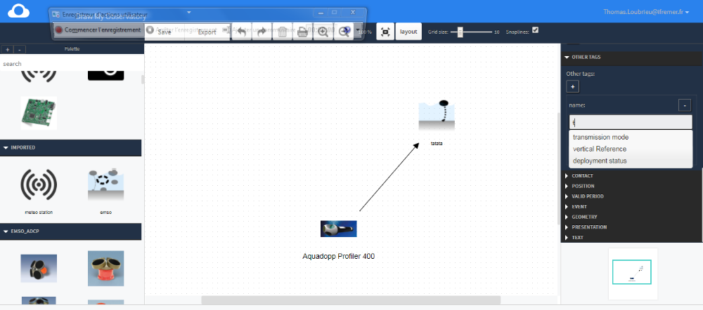
Figure2.3. 15: Screenshot of the Sensor Nanny SensorML Editor
EDI
EDI-NG is an HTML-based editor for sensor metadata, developed by CNR in cooperation with CSIC. Like Sensor Nanny, it is as well openly available via GitHub: https://github.com/SP7-Ritmare/EDI-NG
Besides the HTML based client component, it also include a separate server component that is used as backend for the editor (e.g. for handling the XML creation). For EDI-NG a core feature is its high level of configurability. This means that this SensorML editor can be configured to different application scenarios using XML templates. These templates ensure a high level of flexibility so that users can define not only the required metadata fields but also make further constraints on allowed values, etc.
Objectives that were addressed by the EDI developments during the ODIP II project comprise:
- Exploit semantic resources continuously curated by external authorities (e.g. NVS2)
- Describe vessels involved in EuroFleets
- Create a new template for instrument calibration history
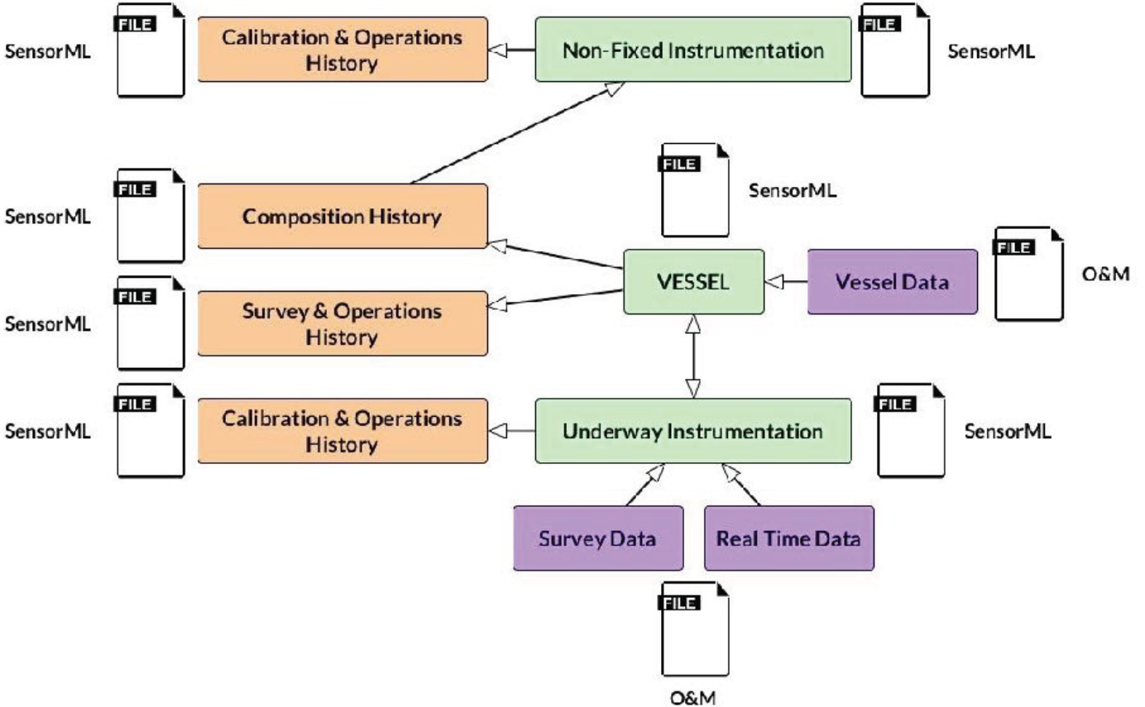
Figure 2.3.16: Overview of the SensorML Model used by EDI
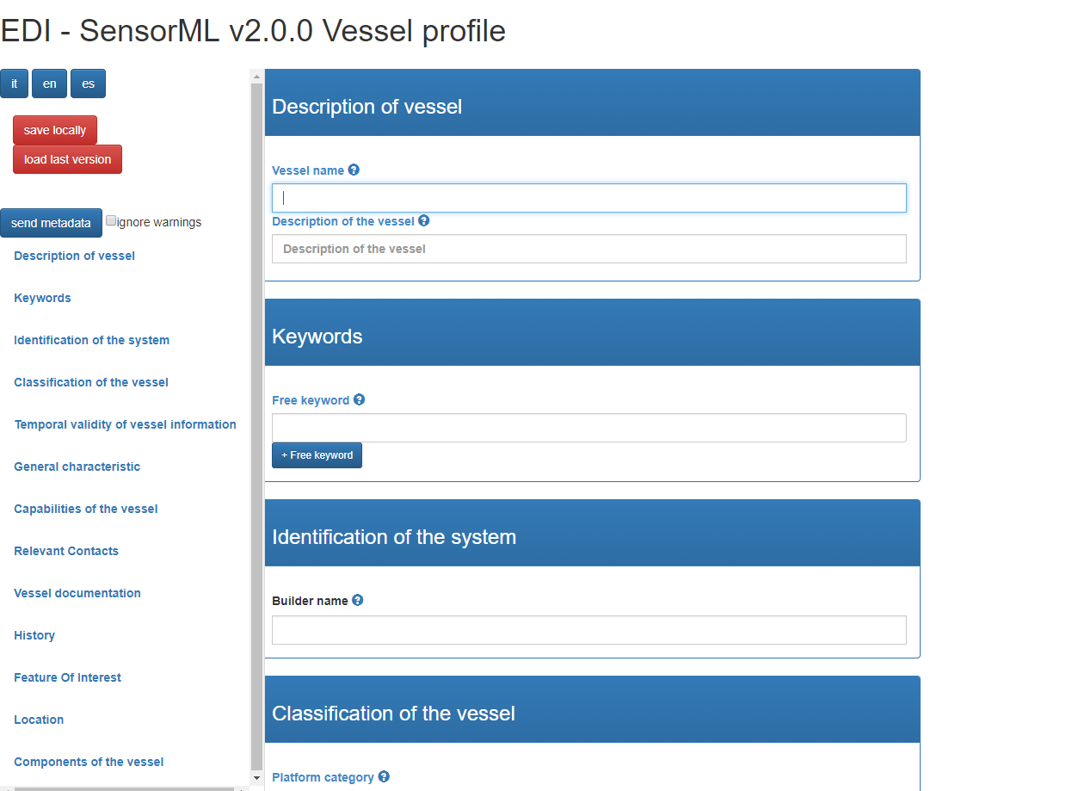
Figure 2.3.17: Screenshot of EDI
smle
The third SensorML editor contributed to Prototype 3+ is smle, developed by 52°North. This open source client, which is developed as part of the NeXOS, FixO3, and SeaDataCloud projects, is available via GitHub, too: https://github.com/52°North /smle
Compared to the other two examples of SensorML editors, smle has a stronger focus on the integration with other Sensor Web Enablement components. For example, smle is able to use any SOS server for storing the created SensorML files, as long as an SOS server supports the transactional operations of the OGC SOS specification.
Core features of smle comprise:
- Support the use of SOS servers for metadata storage
- Domain-independent (could also be used beyond marine sensors)
- Support the use of sensor type information from the ESONET/FixO3 Yellow Pages
Main activities conducted during the second half of the ODIP II project comprise:
- Evaluate the tasking of sensors by editing SensorML-based descriptions of sensor parameters
- Login mechanism to control write access (as part of the FixO3 project)
- Allow the description of sensor interfaces (commands, parameters, outputs) as part of the SeaDataCloud activities
- Use the NERC Vocabulary Server for looking up definitions and values of soft-typed SensorML properties
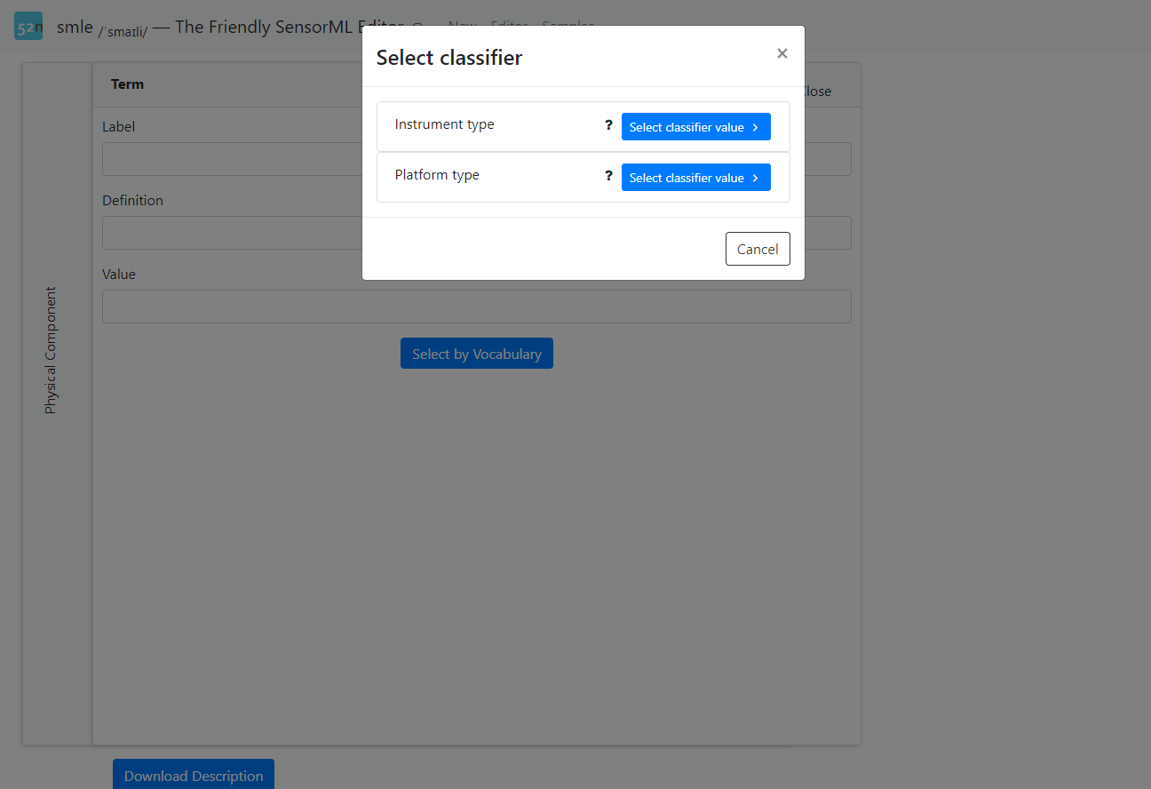
Figure 2.3.18: Screenshot of smle Consuming Classifiers from the NERC Vocabulary Server

Linking between Sensor Web and Global Infrastructures such as GEOSS
Supporting the linking between Sensor Web services and global infrastructures such as GEOSS was another goal of this work package. To support this, a similar approach like in the hydrology domain (GEOWOW project) was chosen: through the work on common Marine Sensor Web profiles (see above) it is possible to offer common entry points into marine Sensor Web services. This allows GEOSS Common Infrastructure components such as the GEOSS Discovery and Access Broker to harvest metadata from marine SWE services and to make these resources discoverable and accessible through GEOSS.

Promoting Sensor Web Technology
The developments performed within Prototype 3+ were presented at several workshops and conferences in order to promote the application of Sensor Web technology. Especially the following four events should be mentioned in the context of these prototype development activities:
- OGC TC Meeting Delft: At the OGC TC Meeting in Delft in March 2017 52°North presented the activities of the Marine SWE Profiles Working Group to the OGC community.
- EGU General Assembly 2017: There were several presentations of ODIP II Prototype 3 results:
  - 52°North and AWI: A Query Language for Handling Big Observation Data Sets in the Sensor Web (Christian Autermann, Christoph Stasch, Simon Jirka, and Roland Koppe)
  - AWI: An integrative solution for managing, tracing and citing sensor-related information (Roland Koppe, Peter Gerchow, Ana Macario, Ingo Schewe, Steven Rehmcke, and Tobias Düde)
  - BODC: Using URIs to effectively transmit sensor data and metadata (Alexandra Kokkinaki, Justin Buck, Louise Darroch, and Thomas Gardner)
- Geospatial Sensor Web Conference 2017: At the Geospatial Sensor Web conference organised by 52°North in August 2017, the ODIP II developments were highlighted during several presentations and a Sensor Web tutorial.
- ESRI Development Center Forum 2017: Presentation by 52°North on the topic “A Query Language for Handling Big Observation Data Sets in the Sensor Web”
- Oceanology International 2018: Sensor Web presentations by several ODIP II partners at the workshop “Training workshop – Interoperability technologies for sharing ocean instruments and real-time data”
- EGU General Assembly 2018: Although the project ended before the conference, 52°North was able to present an overview of the Prototype 3 results in the session “ESSI1.1 - Informatics in Oceanography and Ocean Science”

ODIP Prototype 4

Prototype 4 ‘the digital playground’ was formulated to explore, review, and formulate common solutions and best practices for setting up and configuring cloud based Virtual Research Environments in the marine domain, dealing with a great variety of data types, processes, user classes, big data, and both operational and delayed mode data services.
It was led by MARIS (Europe) together with CSIRO (Australia).

2.4.1 Analysis
A range of relevant existing projects and initiatives have been reviewed and analysed, looking for common developments as well as specific promising solutions for setting up VREs:
- NOAA’s Big Data Project (USA)
- Galway Bay subsea cabled observatory (Europe)
- Data Quality Strategy at the National Computational Infrastructure (Australia)
- The EVER-EST project (VRE) (Europe)
- Climate Information Portal for Copernicus (CLIPC) (Europe)
- Nectar Research Cloud, MARVL, and Australian Marine Sciences Cloud (Australia)
- eReefs (Australia)
- Australian Urban Research Infrastructure Network (AURIN) (Australia)
All these initiatives are described with their characteristics in the ODIP II Deliverable D3.2.
From the ODIP II workshop sessions and the analysis of the big data and virtual research environment projects / systems it can be observed that these all revolve around ‘integration’ of marine data: i) bringing together data from real-time and near real-time data services and from large archives and repositories; ii) undertaking analyses and various forms of processing, arranged in workflows; iii) publishing and visualizing data and data products; iv) reproducibility of calculations and analyses. Thereby we have to deal and find solutions for the increasing volume, velocity and variety of the data sets. To overcome barriers of increasing volume, programming codes and data sets can be moved to remote machines such as provided by cloud infrastructure. This poses technical and organizational challenges how to set-up and make use of such configurations. Increasing velocity gives technical challenges such as developing real-time quality control algorithms, overcoming performance issues because of large throughputs, and guaranteeing continuity of data streams in case of hick-ups in data streams from the field towards the receivers. Increasing variety poses interoperability challenges which can be tackled by applying standards for metadata and data formats, supported by controlled vocabularies, both for machine-to-machine services and human interfaces. This way automated workflows can be set-up, combining various analysis and process services, and multiple types of data and data products.
According to Candela et al. (2013), the main characteristics of a Virtual Research Environment (VRE) are:
- web-based environment,
- designed to serve a community of practice,
- provide tools and services to accomplish the community's goals,
- open and flexible,
- promote fine-grained controlled sharing of both intermediate and final research results by guaranteeing ownership, provenance and attribution.
This corresponds quite well with the observations made on existing initiatives and the ODIP II understanding. The ODIP II analysis and international discussions have provided a major input for the architecture that has recently been drafted for a VRE as part of the SeaDataCloud project. This will be highlighted as a way to illustrate how VRE challenges might be overcome in practice.

2.4.2 Architecture for VRE for SeaDataCloud

A VRE can be characterized as a web-based workspace providing seamless access to all services a researcher needs to do her work and collaborate with her community:
- Finding data
- (Centralized) access to data
- Processing of the data
- Visualisation of data/results
- Sharing of results with colleagues and/or with a wider public

The SDC VRE needs:
- Facilitate collaborative and individual research: Using, handling, analysing and processing ocean and marine data into value-added data products which can be integrated, visualised and published using high level visualisation services.
- Combine internal data with subsets from other data resources, such as ingested collections
- Have a high capacity and performance for big data processing and state-of-the-art web visualisation services
- Respect privacy of users and differences in data policies. Differentiated users, different access to data and data products.
- Make it possible to configure virtual work spaces for individuals or groups to work on specific projects, including setting up of dedicated pools of data
- Allow producers to decide whether their outcomes will be shared in the public domain or stay private
- Should be based on EUDAT’s infrastructure.

Observations from the studied VREs:
- Mostly the same expectations with respect to community building, data sharing, processing and analysis tools
- Authorisation/Authentication layer both in portal layer as well as on top of service layer
- API’s for each (processing) service
- Communication standards are key to success
- Front end applications are various: From self-created workflows, to VRE virtual labs, to dedicated user interfaces. But all run on same set of services and data.
The VRE to be developed for SeaDataCloud is targeting a number of use cases. Each use case concerns a specific community which brings together resources (data collections, processing, tools) for a targeted group of users and applications. The overall VRE architecture to be specified for SeaDataCloud should be fit for implementing the 5 use cases. The leading use case concerns the development, update and publication of data products for European sea regions consisting of regional climatologies for temperature and salinity observations in the water column.
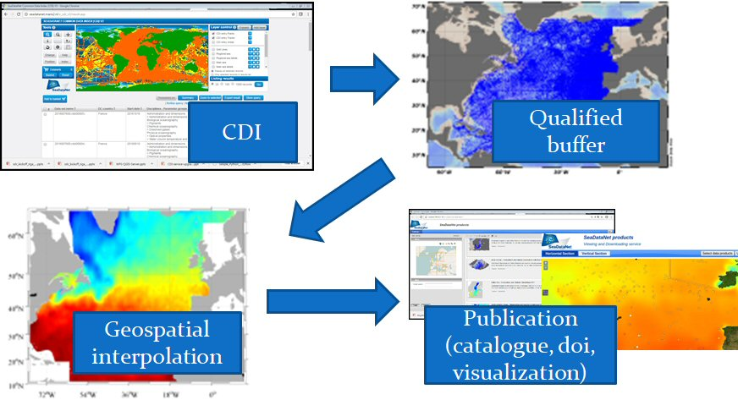
Figure 2.4.1: SeaDataNet use case for the generation of Temperature and Salinity data products
This is organized by having per sea region a regional task leader, applying a common methodology and workflow, to analyse and process a large regional observation data collections into regional climatologies, thereby taking into account integration and tuning at the edges where the geographical regions touch or overlap each other. The regional task leaders run geostatistical analyses of water-column temperature and salinity from gathered and compiled SeaDataNet observation data collections. The workflow goes from data selection to geo-spatial analysis using DIVA software and product publication, through collaborative manned quality assessment with ODV software.
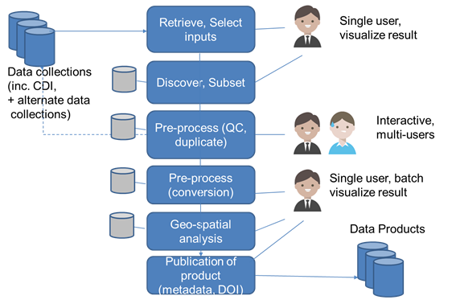
Figure 2.4.2: SeaDataNet detailed workflow for the generation of Temperature and Salinity data products
The SeaDataCloud Virtual Research Environment (VRE) needs a number of basic components to fulfill the functional and non-functional requirements as extracted from the use case. The components can be divided in generic service components and dedicated VRE components.
The generic components are part of the following layers of the system:
- Processing service layer
- Security/Authentication layer
- Data access layer
- Integration layer / Graphical User Interface (GUI)
The layers are depicted in the figure below. This figure includes selected software packages or services as provided for SeaDataCloud through the SeaDataNet infrastructure or the EUDAT Cloud infrastructure.

The integration of the services will take place in the “VRE portal”. This layer will provide users access to the services and data that are part of the VRE. The portal will offer user interfaces in various “flavours”, from very technical/scientific (JupyterHub, Virtual labs) to interfaces created for less scientific users (dedicated interfaces). In the EUDAT Cloud infrastructure all calls from interfaces to services and data should go through an HTTP-API in a standardised way. The HTTP-API is to be provided by the EUDAT cloud infrastructure and can be seen as the glue between the VRE portal, and the different layers.

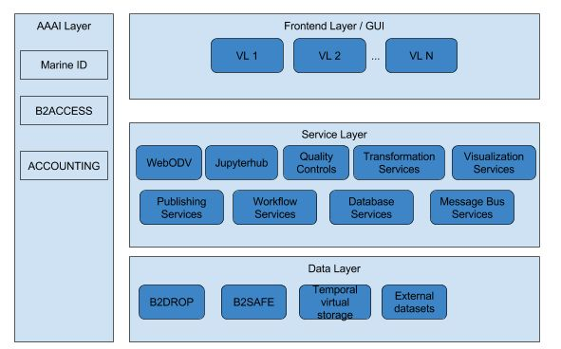
Figure 2.4.3: Diagram of layers in the architecture

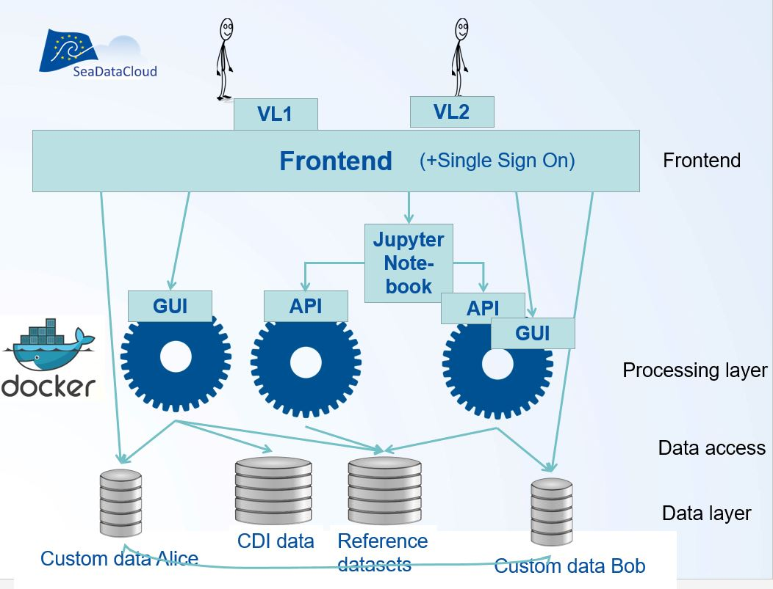

Figure 2.4.4: Diagram of components and services in the SDC VRE
The core of the VRE architecture is to be developed by EUDAT, a consortium made up of European data centres. However, some of the API’s that will be available in it will be developed by different parties. The applications will be provided as “docker“containers that run on EUDAT computing centres. The use of containers for the services is a necessary step as it makes it very easy to deploy and upgrade services and to run the services in their own environment. Docker containers will be loaded with a pre-installed instance of the software. Docker containers are particularly well suited to bundle applications with all their dependencies and to easily deploy them on different systems. In principle, a Docker image will be generated to carry out a single service. For the VRE, considering the number of services that should communicate with each other and run on a cluster within their containers, a more complex architecture might be needed.

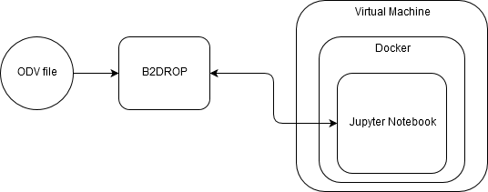

Figure 2.4.5: Simple workflow linking data and notebooks.

A container orchestration might be needed in case of running multiple services at the same time. For that purpose Kubernetes might be a good candidate. It is an open-source system for automating deployment, scaling, and management of containerized applications.
The services can be approached by dedicated user interfaces (GUI) and machine interfaces (API). In case an API consists of several functions, the use of Kubeless might be a valid option. Kubeless is a Kubernetes-native serverless framework that lets a user deploy small bits of code (functions) without having to worry about the underlying infrastructure. It is designed to be deployed on top of a Kubernetes cluster and take advantage of all the great Kubernetes primitives. Kubeless is compatible with serverless. This allows contributors to upload functions to the VRE cloud in the same way as they would to other cloud providers.

2.4.3 Notebook services
A way to make specific services available to users is to use Notebooks services. A notebook service is an online command line interpreter to edit and run customized snippets of code. It also provides a visual interface for accessing data resources and processing software. Notebooks constitute a convenient way to describe a complete procedure that goes from a raw dataset to a final product after the execution of several operations. Notebooks are a practical way to share research methods and findings and it is more and more often recognized as a powerful tool for collaborative research. Writing tutorials as text and code snippets is one of the most popular uses of this tool. Although many different notebook solutions are available, the SDC VRE will make use of Jupyter Notebooks, which now support more than 40 language kernels. It evolved from IPython, a command shell for interactive computing initiated in 2001. Jupyter is now widely used by scientists and its use is made easier by JupyterHub, the multi-user server for Jupyter notebooks. JupyterHub handles the authentication of the users and starts the Jupyter notebooks in a predefined working environment. The working environments are Docker containers with all necessary software pre-installed. Jupyter Notebooks deployed from a JupyterHub will be used to implement this notebook service.

Jupyter notebook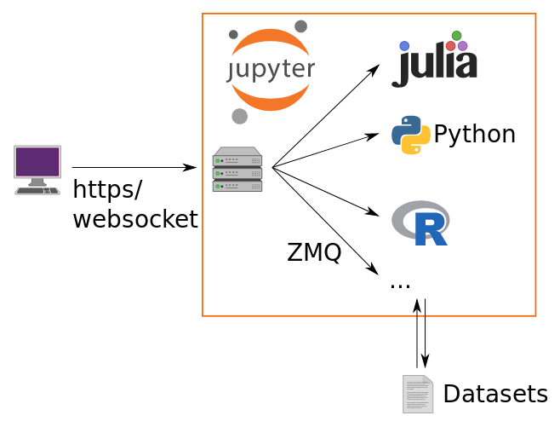 | Jupyterhub 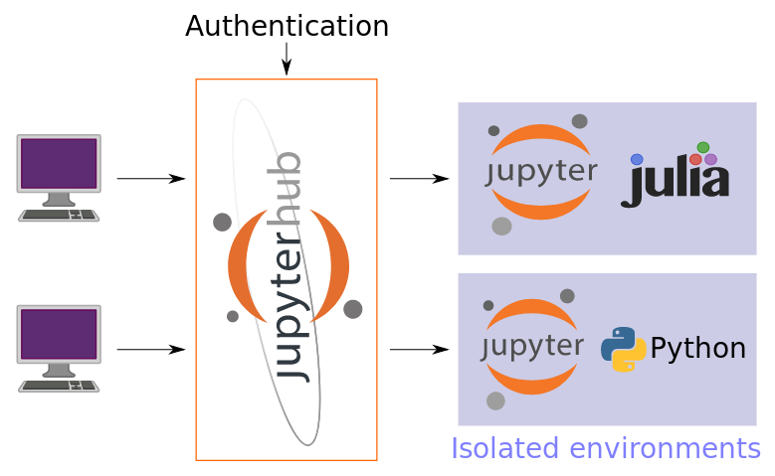
Figure 2.4.6: Overview of the architecture of Jupyter notebook and Jupyterhub. Jupyterhub is based on Jupyter notebook.

2.4.4 DIVA software as one of the VRE processing engines

DIVA will be a component of the VRE and therefore an online version of the DIVA software is being developed. DIVA: stands for Data-Interpolating Variational Analysis and is a software tool designed to spatially interpolate in situ data and generated gridded field using an efficient finite-element solver. (https://github.com/gher-ulg/DIVA).
The objective of DIVA (Data-Interpolating Variational Analysis) is to generate a set of gridded fields, often called “climatology”, from in situ observations. The interpolated field should be at the same time relatively close to the observations (it should not necessarily pass through all observations because observations have errors) and “smooth”, meaning that it does not exhibit too strong gradients or irregularities.
DIVA developments were initiated more than 20 years ago and it is by now a complex software tool consisting of bash scripts calling executables obtained from the compilation of Fortran code. Recently, a new DIVA code called DIVAnd was written and released (https://github.com/gher-ulg/divand.jl). The mathematical formulation of the new DIVAnd is a generalization from the previous version, as it now allows the interpolation in more than 2 dimensions (typically: longitude, latitude, depth and time). The code has been rewritten in the programming language Julia. This provides a good trade-off between efficiency of a compiled language and flexibility of a dynamic language. The language draws several interesting concepts from other programming languages and is a good fit to re-implement DIVA, because it has a good support of linear algebra primitives and borrows several model programming concepts from Python and other modern languages, such like lambdas, iterators, generators and macros.
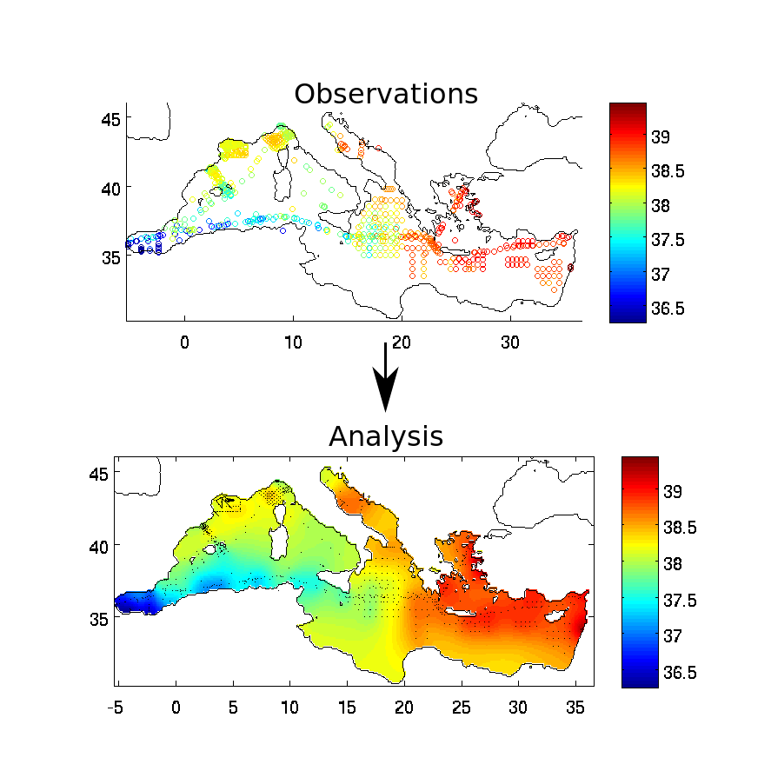
Figure 2.4.7: DIVA and DIVAnd tool allow one to derive a continuous field from discrete observations; the example illustrates the gridding of salinity observations in the Mediterranean Sea.

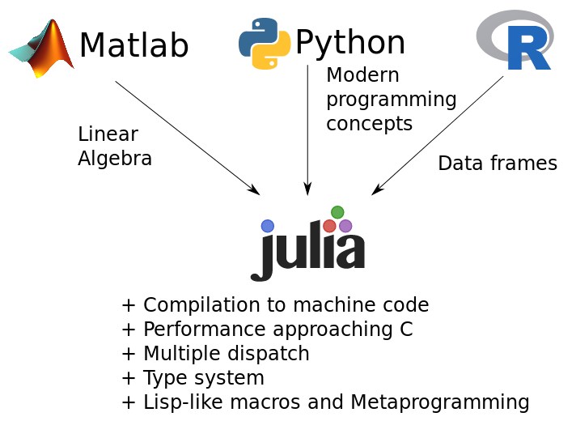
Figure 2.4.8: Programming languages that influenced Julia and list of distinctive features.
In the frame of the VRE developments, the use of DIVAnd is particularly relevant as it provides users with an access to a powerful software tool coupled to a huge amount of data, without having to install anything on their local machine. Users have also the possibility to use their own data in combination with the datasets made available by the SeaDataCloud consortium.
DIVA as Jupyter notebook:

The Jupyter notebook format has been adopted as the solution for the users to execute code fragments leading to the generation of the final products using DIVAnd. The notebooks are suitable as they combine:
- code fragments that can be run successively,
- text cells that describe the code and at the same time constitute the user guide and
- figures or animations that illustrate different steps in the process, for instance: data locations, duplicate removal, gridded and error fields.

Notebooks can be exported to HTML and PDF (among others) and they are easy to share, using tailored platforms like https://nbviewer.jupyter.org/, but also code hosting platforms such as GitHub and Bitbucket (using a plugin) render Jupyter notebooks. Sharing notebooks along with the generated products strives to improve the reproducibility and the peer-review (of DIVA climatologies in particular). Thanks to its LaTeX support, it provides high-quality type-setting of complicated equations.
Julia includes several “hooks”, which makes it easy to integrate it in a Jupyter notebook. In particular, it allows one to nicely format Julia object using HTML. This is used in DIVAnd for example to display additional metadata information of observations by embedding the corresponding web-page.
The main challenge to overcome is the interaction with the other components of the VRE, in particular:
- Ocean Data View, which will provide data files that will be ingested. Using the Jupyterhub environment it was demonstrated that it is possible to retrieve data from webODV using its REST API and launch an analysis with DIVAnd.
- The visualisation services, which will provide an additional support for static and dynamic visualisation of data locations, profiles and time series.
- Integration with suitable logging services to monitor the usage of the system.
Initially, an OGC Web Processing API, the Web Processing Service (WPS, http://www.opengeospatial.org/standards/wps), was considered as the suitable protocol to interact with DIVAnd. However during the course of the project, a more lightweight REST API turned out to be preferable. On top of the DIVAnd REST API, a wizard-like HTML interface will be implemented.

ODIP Prototype 5
The ODIP prototype 5 investigated the current practices of animal tagging data. Bio-telemetry constitutes a powerful technology to collect remotely unprecedented insights into animal movement behavior and social interactions, and physical environment. The merging of oceanography and marine mammal ecology advances our understanding of the world’s oceans and its top predators, and allows us to predict how these species will be affected by future climate changes. At the same time, using organisms as sensor platforms provides very valuable information on the physicals state of the oceans. However different communities use different data systems and data standards. Exchanging these data between biological and physical data systems will add value. A prototype focusing on marine mammal tracking data aiming at a better integration of data management principles between biological and physicochemical marine data was proposed within the context of ODIP. Within the current ODIP project the conceptual idea on how to better integrate data stream was further being discussed, however full implementation is not within the scope of the project.

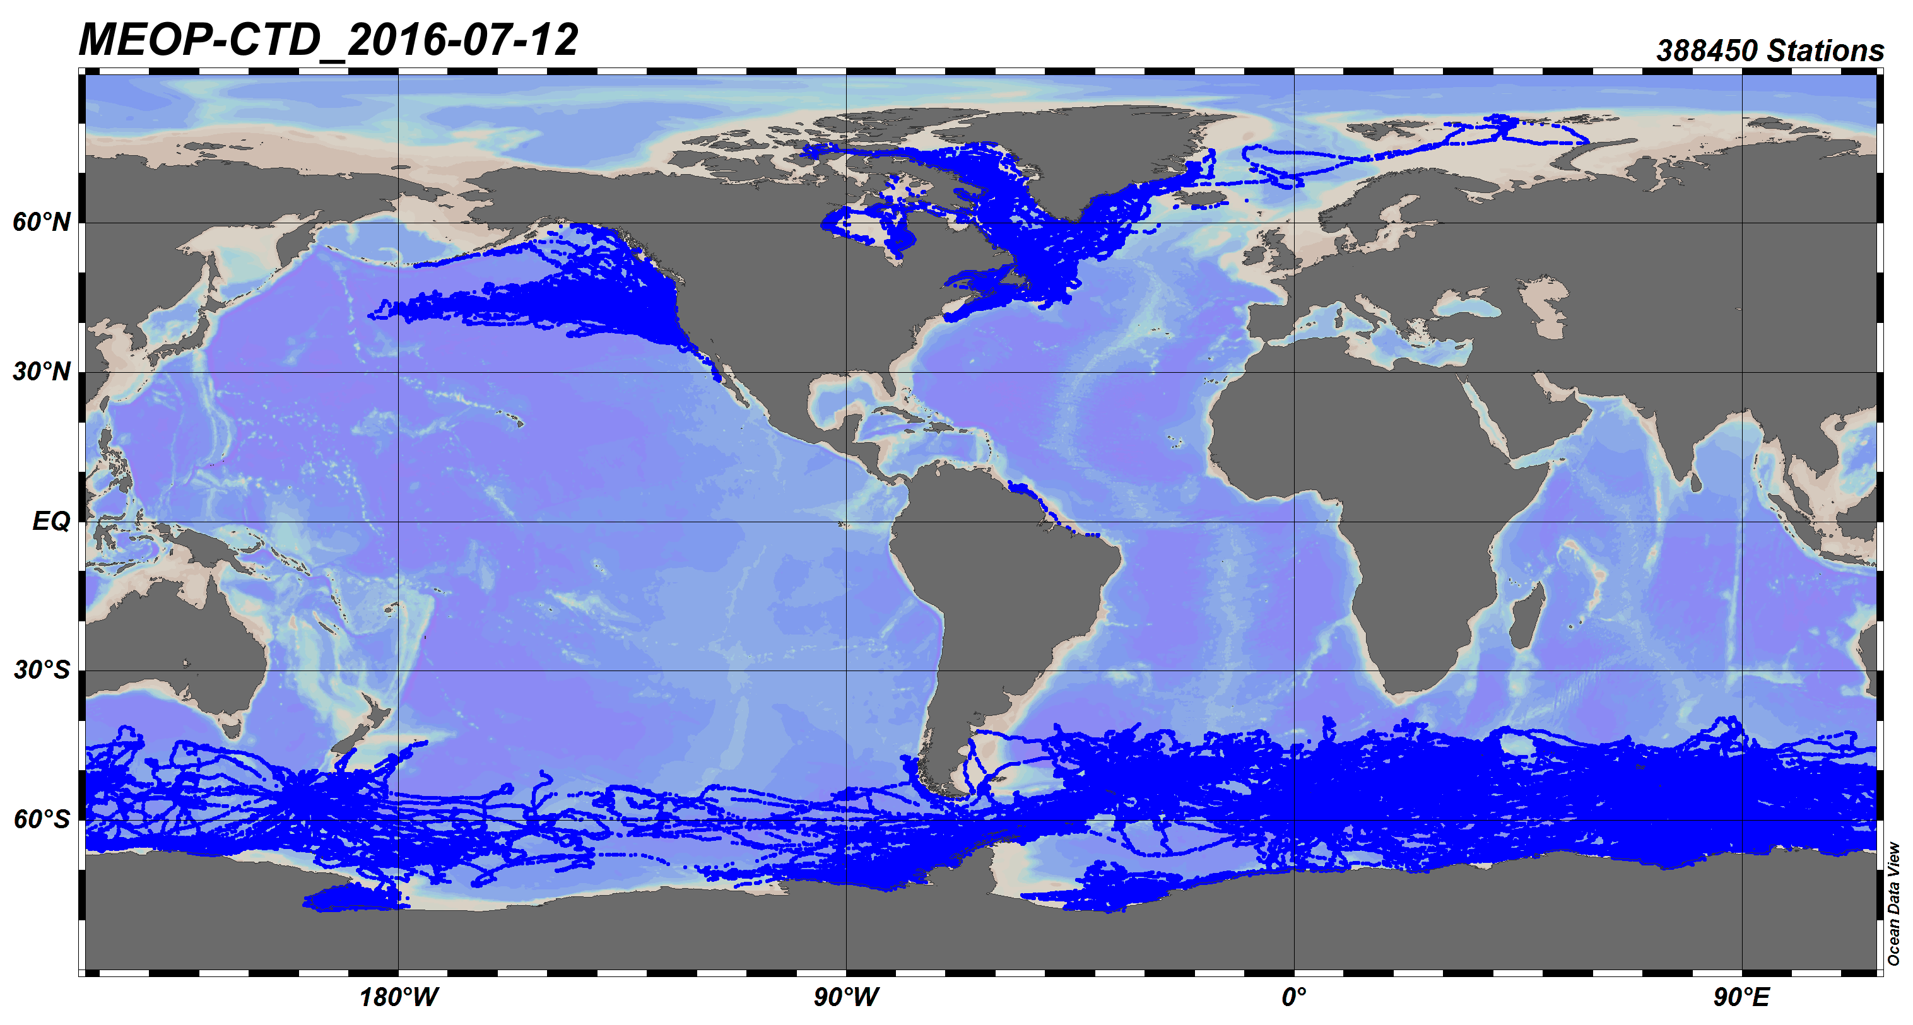
Fig 2.5.1: Spatial overview of MEOP tracking data, 07/2016
Bio telemetric data provide information on the physicals state of the oceans, but also on the occurrence, behavior and migration of the tagged animals. Therefore, these datasets are useful to include in larger integrated data systems focusing on Marine Biogeographic data and Marine Oceanographic data. This porotype would allow to further investigate the different existing data schemes and analyze how they could ideally interfere with global thematic marine data schemes. It will also be relevant to examine in general differences between marine data schemes developed within different communities (biology and physics).
One of the major marine bio-telemetric data systems, using both acoustic telemetry and satellite tagging (biologging) is undertaken by IMOS and focuses in the Southern Ocean and southern Australia. Over 15 national & international partners contribute to this major undertaking currently containing 360 CTD satellite tags deployed between 2007 – 2017, accounting for 175,000 CTD profiles and over 3 million measurements. Within MEOP (Marine Mammals Exploring the Oceans Pole to Pole) currently over 300,000 profile are available. This data is currently served as Real-time data. BODC support the near-real-time supply of SMRU Seal Tag data to the GTS via the Met Office for operational use. However more could be done with the delayed mode data through integration in specific global and European Biological and Oceanographic databases (OBIS, SDN, EMODnet).

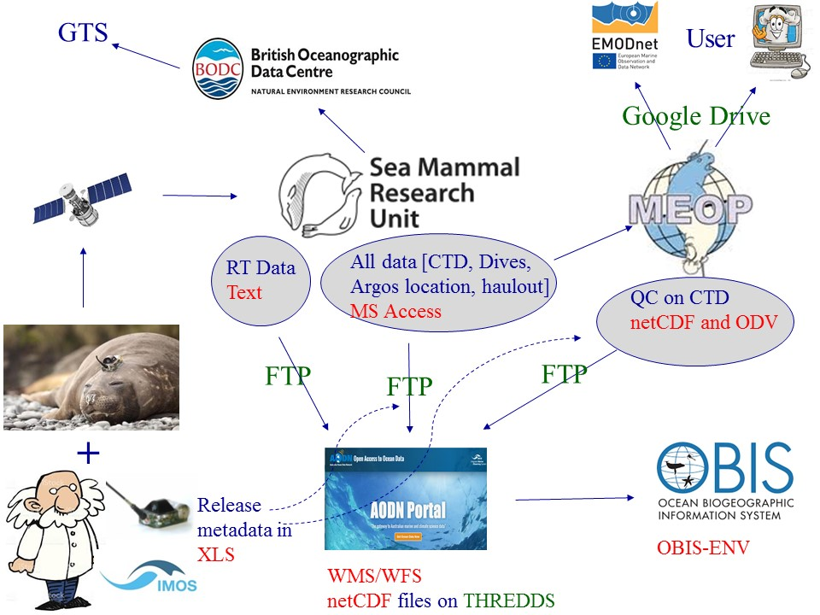
Fig 2.5.2: Scheme visualizing dataflow for biologging data. Dataflow of delayed mode data should be improved.

Through OBIS-ENV-DATA, OBIS has successfully developed information technology solutions for combined data, as recommended in the OBIS-ENV-DATA proposal in 2015, as adopted by the IOC Committee on IODE. The combined data identified in the OBIS-ENV-DATA proposal addresses datasets provided to OBIS that include both biological and environmental data (hence "combined" data).
OBIS's technology solution addresses not only combined biological and environmental data, it also incorporates details about sampling methods and effort, it expands OBIS's capacity for biological details, it enables OBIS to organize, aggregate, and link ocean observation events using "event hierarchy" and it implements identifiers to reference standard vocabulary for the parameters involved in biological, environmental, and sampling details. Also as recommended in the OBIS-ENV-DATA proposal, OBIS's solution maintains compatibility with Darwin Core, including use of the Darwin Core / GBIF capability known as "Event Core". OBIS can now refer to this complete combination of data features, including biological, environmental, sampling details and event hierarchy, as "OBIS Event Data".
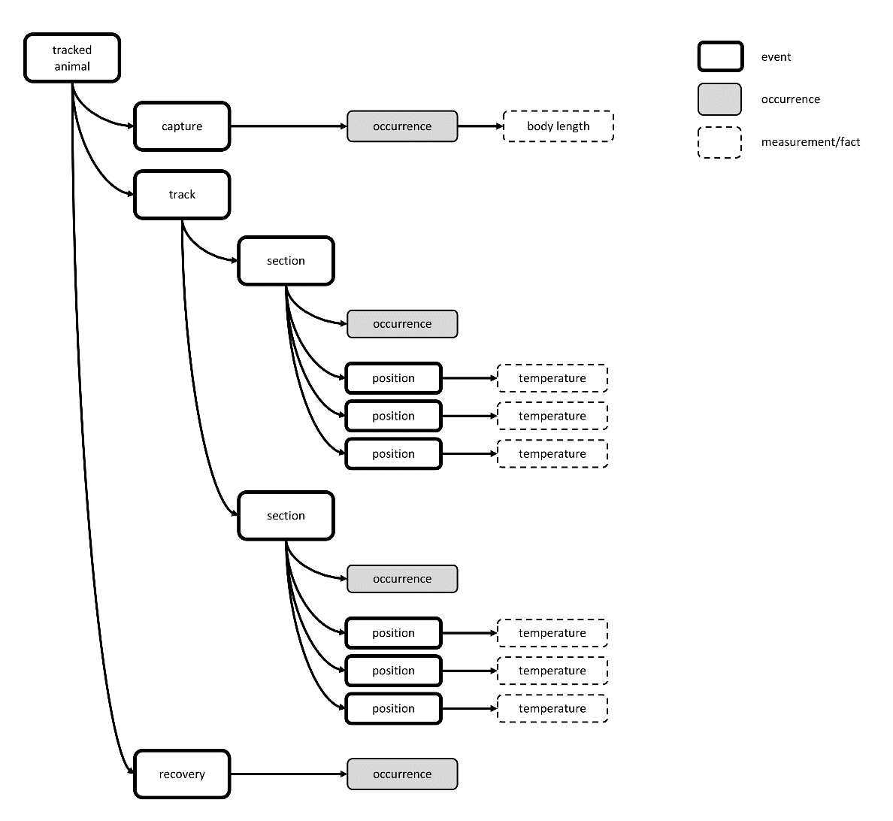
Fig 2.5.3: Conceptual example on how delayed mode bio-telemetric data can be stored using the OBIS Env Scheme.
A hypothetical example on how to capture bio telemetric data using the OBIS Env scheme has been worked out. It is based on the IMOS - AATAMS Facility - Satellite Relay Tagging Program - Near real-time CTD profile data and published at: http://ipt.iobis.org/obis-env/resource?r=imosrealtimectd
as a DarwinCore-Archive.
This scheme allows to describe the release occurrences with the high variety of biometric measurements and the recovery events. It allows also to group the different tracks by time (weeks) and links to the CTD readings.
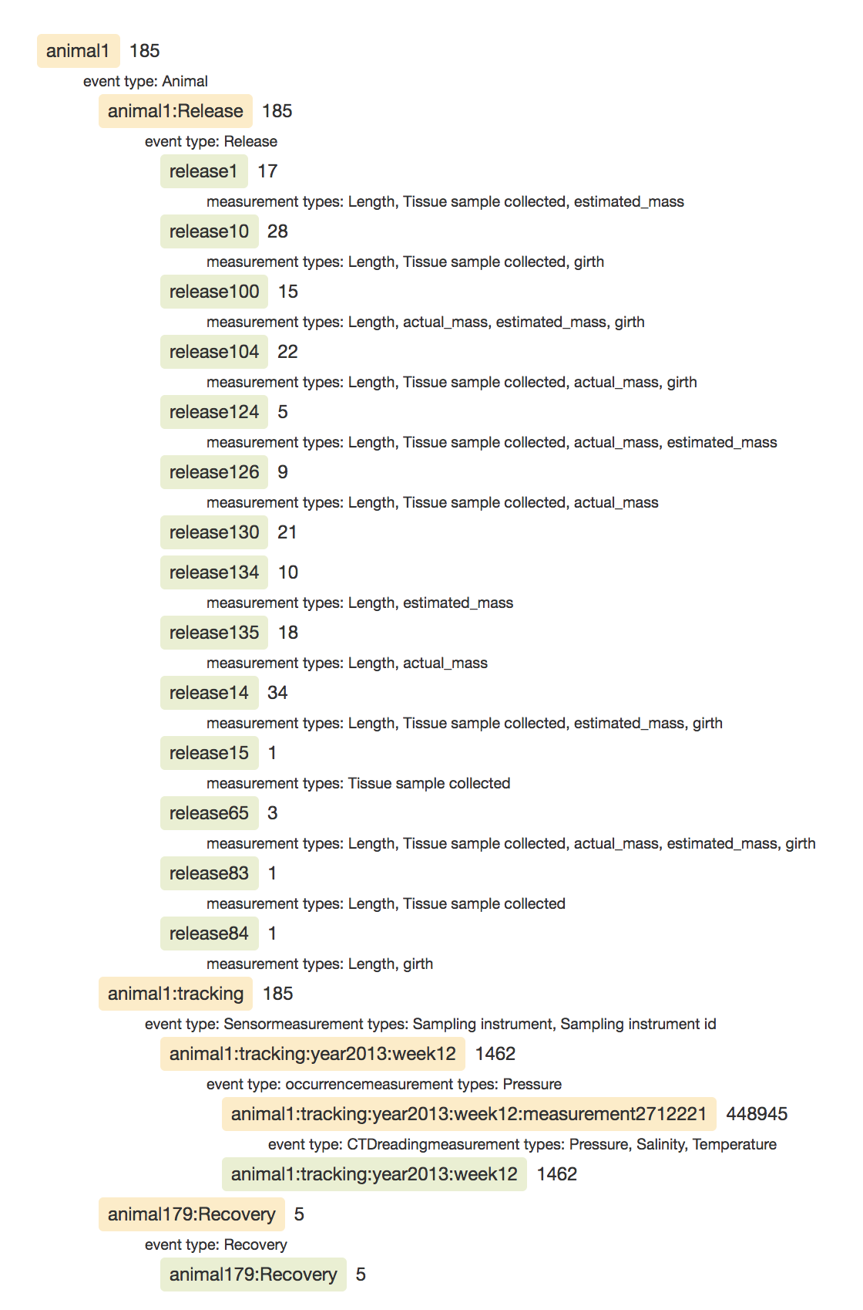
Fig 2.5.4: Example on how delayed mode bio-telemetric data can be stored using the OBIS ENv Scheme.
The OBIS Env-MEOP example can be considered as a successful case were mixed data were integrated in a different community standard. In order to fully meet the potential and objectives, the community should further work on:
- Integration of biological data in global biogeographic and oceanographic data systems
- Availability and use of appropriate existing data standards suitable for seal tag management
- Use of existing controlled vocabularies for use in the data standards
- Use of suitable exchange format compliance checkers

Documenting and Sharing Best Practices - The Challenge, Status and Future Vision
The complexity of ocean observing systems is rapidly increasing as requirements for simultaneous biological, physical, and chemical observations emerge to inform new societal requirements. There are many examples in biogeochemistry and biology with new and exciting outcomes, but these may not be comparable quantitatively because of variations in observation methods and data archiving. Moving toward consistent, quantitative science outcomes is essential to address challenging global issues of changing climate, etc. For this, a major capability needed is access to and the ability to use rigorously tested and community accepted methods (“Best Practices”) in ocean observing including ocean data archives. Such “Best Practices” (BP) have helped promote activity across disciplinary boundaries, as well as supporting training of new observers and analysts. They support reproducibility of science and the transmission of key methods across regions. Fundamentally, the use of BP underpins science at a national, regional and global scale.

The increasing use of big data also drives the need for standard protocols for data preparation and insertion into models. The efforts for BP under the ODIP II project addressed both current and future issues associated with data management of ocean information and the creation of a system of BP to support efficient access, provenance, quality assurance and user engagement. The goal is to increase efficiency, reproducibility, and global interoperability of the ocean observing value chain by defining and building elements of an Ocean Best Practice System, ultimately providing the ocean observing community with a unified, sustained, and readily accessible knowledge base of interdisciplinary best practices (BP) for both observations and data management.

3.1 Challenges
Ocean observing systems/infrastructures must be capable of converting raw data into usable information and knowledge products stored in repositories that are readily accessible to scientists. Methodologies/BP must engage all aspects of the end-to-end information processes ranging from defining and implementing observation plans to the deposition of high-quality data in repositories and effective distribution to scientists and other users. This needs to cover scientific and societal needs, including (but definitely not limited to) citizen science, ocean dynamics, coastal and fisheries management, marine safety, education and national security. Typically each element of the value chain maintains its own information infrastructure. This does not work well for interdisciplinary collaborations. For these, interoperable “best practices” can make a significant contribution.

What is a best practice? During the last year, through ODIP co-sponsored workshops, side meetings and in presentations, this has been discussed by our community. From these discussions, a best practice definition evolved to be: “A community best practice is a methodology that has repeatedly produced superior results relative to other methodologies with the same objective. To be fully elevated to a best practice, a promising method will have been adopted and employed by multiple organizations.” Further evolution is likely as the use of best practices expands.

Oceanographic data are generally challenging and expensive to acquire, and they are gathered to address a broad spectrum of needs – from simple local recreational interests to documentation of the long-term changes to our planet. The methods used to make and deliver these measurements may be “best” because they are cost efficient, or simple, or reliable, or they may be “best” because they provide the most accurate, or the most standardized, or the most spatially comprehensive observations. The important common element is that the best practice employed by an operator or user satisfies their specific requirements. It is the practice they have found to be the best solution at the time of implementation. There is rarely, if ever, one best practice. They will vary among applications and they will vary over time. The challenge is to most effectively share and document the many best practices already in place, to facilitate the evolution and improvement of them, and to ensure they are readily available for use.

A second challenge is in the propagation of best practices. Often, best practices do not rise to publication in a scientific journal. Indeed, in many instances they may not even be documented at all, residing solely within individuals who pass the information along verbally. This process has worked for generations in universities and research institutes. When the community is small it works well. However, as we move to global monitoring on a granular scale, the number of people doing a specific measurement increases to the point that verbal conveyance of practices is not sustainable (Riebesell, 2011). From this perspective, documentation becomes essential. Documentation in a drawer has little impact and so the challenge is to make best practices discoverable and accessible. Thus an open, accessible and sustainable system of broadly accepted methodologies is needed as ocean observing expands.

A third challenge is in planning and supporting reproducibility in science research. The methods of creating a research outcome need to be well documented so that the results can be replicated a decade or two later with preserved data and clearly documented methodologies. This is possible in some climate studies, but the research community has not addressed this challenge in a comprehensive way.

These and other challenges point to the need for an ocean best practice system as a long term sustainable capability supporting observations, data management and user needs for modeling and societal decisions.

3.2 The Ocean Best Practice System
An Ocean Best Practices System (the “OBP-S”) has been designed under ODIP II to address the above challenges and others (Pearlman et al., 2017). This solution covers the entire range of ocean observations, addressing improvements of observation capabilities - including data management and user support. The OBP-S has three core elements: (1) a sustained, advanced repository and communication system; (2) a community environment for BP documentation, evolution and adoption; and (3) methods and collaborations for training and professional advancement. This recognizes that to preserve their value, BP need to be accessible, searchable, and comparable across disciplines (e.g. EOVs). In this, we are guided by the FAIR principles (Mons 2017). Advancing technologies can be adopted in knowledge representation, linked data, natural language processing, and document managements (https://www.oceanbestpractices.net/), where key documents of the global observing communities can be easily accessed. This will have an impact, e.g., on the development of QA/QC methods that have seen significant efforts in diverse projects such as European JERICO and FixO3 projects, IOOS QARTOD, EMSO ERIC and others whose best practices have not consistently converged. The OBP-S will provide community mechanisms for dialogues to facilitate defining and publishing BP that can synthesize methods. One aspect of this effort is the recently created Research Topic in Frontiers of Marine Science (https://www.frontiersin.org/research-topics/7173/best-practices-in-ocean-observing), which will become a place of commentary and dialog. The third element of the System is training - a two way process including feedback that can support evolution and expansion in use of BP. The ODIP II project has played an important role in the concept formulation and the initial implementation of the OBP-S, which consists of the following specific developments

OBP Repository:

The Ocean Best Practices repository (OBP-R) is the IODE repository for best practices (https://www.oceanbestpractices.net). The technical implementations resulting from ODIP II are designed to enhance the functionality and search capabilities. A key requirement is to enable easy discovery by practitioners with diverse backgrounds, both technical and cultural. Thus, supporting user search needs flexibility. The Repository (OBP-R) offers the use of advanced semantics and, in the next generation, natural language processing to improve BP discovery. Another feature of the new system is the tagging of document content. Best practice documents can be comprehensive, containing many best practices in a single document (Coppola et al., 2016). In such cases, a singular practice may not be easy to find. Content tagging at a granular level allows easy discovery of details. These tools promote and increase the value of present content in the Repository.

There are a number of other benefits to a central sustainable OBP-R. The repository supports machine-to-machine interfaces. With a standardized search methodology and the assignment of DOIs, citation tools including Google Scholar have ready access, providing wider dissemination of best practices. The open source software used for the search tools also provides a development platform for enhancing growth and community support.

OBP Peer review:

Peer review of best practice documents is a means of promoting community adoption and can provide increased visibility of methodologies. It also has significant benefits for those in universities and elsewhere that use number and quality of publications as a metric for advancement. The current methods of review for best practices are inconsistent. In larger networks and programs, there may be a formal review process for feasibility and practicality. Even here, the knowledge base of reviewers may be limited to their operating environment.
To stimulate peer review, a dedicated open, peer-reviewed journal environment was created in the Frontiers in Marine Science in the form of a “Best Practices in Ocean Observing” research topic https://www.frontiersin.org/research-topics/7173/best-practices-in-ocean-observing. Working together with Frontiers, the Research Topic offers this as the medium to describe and disseminate information about robust and high-quality methodologies and interoperability, linked and referenced to the OBP repository documents as appropriate.

For those practices not going through the journal, originating communities may chose to support peer review of their practices. In all cases, peer review is optional and documents may be submitted to the repository without prior review. Users, searching the repository, may select to see only those practices with peer review.

OBP Training:

Training and capacity building are essential for broad BP adoption. For OBP-S, this will be done working closely with established organizations such as IODE Ocean Teacher, POGO and the SCOR Committee on Capacity Building as well as other activities such as the summer schools run by IMBER, SOLAS, GEOTRACES, etc. It may be in some cases ‘best practices’ are not optimal for Developing Country applications due to costs and so we may need to consider adaptation of best practices. This must be done with the community of experts. Hence, the OBP-S will also target collaborations with the GOOS Regional Alliances and other observing programs which have Developing Countries contributing (such as IIOE2). This will ensure training and access to best practices from a global perspective and also get feedback as to the appropriateness of particular documented methodologies in the OBP-R. As mentioned earlier, it is essential that emerging and mid-career scientists and technicians have access to these best practices and give feedback on their functionality; this can only be done through utilizing them. We will support viewing with mobile systems e.g. tablet and smartphone applications. This will be complemented by social media support. An advantage of this approach is that people have these as tools when they get back from training and can continue using the information and experience of the training. The BP repository will be available as a DVD with the most up-to-date version at the end of the training.

3.3 System Evolution – from Concept to Implementation
The value of the OBP system increases as best practices become more widely available through the repository. The sources of best practices are very diverse. While assumptions are that they originate in research institutions or in observation networks, instrument and platform manufacturers in the private sector also create best practices. Techniques for sensor calibration and use should be part of the sensor design and manufacturing. Some of these practices may be proprietary, but the trend toward open access and pressures from the user community may lead to exchange of information relating to use of sensors. In addition to working directly with potential creators of best practices, the OBP-R is developing a web crawling capability (Kumar 2018, Lopez 2013) to actively search for best practices exposed on the web and then identifying those authors as possible repository contributors.

The work under ODIP II started with a discussion of user requirements and a survey of existing best practices in ocean observation and data management. It became clear that the diversity mentioned above needed to be addressed. Contacts were made with programs such as FixO3 for fixed-point ocean observatories, JERICO for coastal monitoring and JCOMM for global scale observations. For data archiving practices, cruise summary reports (ODIP Prototype 2) have evolved best practices. Approaches for Sensor Web Enablement were also examined (ODIP Prototype 3). The outcome of these examinations and more detailed discussions with IODE clearly pointed that there was no central resource covering all ocean best practices and that documentation tended to vary widely in details and quality.

In order to address this, outreach to observation and data management experts was expanded with presentations to JCOMM, GOOS RAs, POGO, AtlantOS partners, ENVRI +, INTAROS, etc. Presentations were also given at the ODIP meetings, Ocean conferences, the Ocean Science Meeting in Portland, which included a town hall on best practices, EGU and elsewhere.

Through these discussions and interviews, an underlying concept was laid out for a best practices system (Pearlman 2017). To get community feedback, engagement and buy-in, a Best Practices Workshop (Simpson 2017) to review and update the concept was held in Paris, during November 2017, organized under ODIP sponsorship in collaboration with the AtlantOS project (AtlantOS 2017) and the OceanObs RCN. Over two and a half days, thirty-seven participants representing a wide range of international organizations contributed insightful recommendations for the structure, processes and implementation of the Ocean Best Practices System.

The workshop participants strongly agreed that there is a clear need for a consolidated open access repository for ocean observation best practices that would provide consistent open access support to the community. The participants recommended that there be a near term pilot in early spring 2018 as well as a full operational system in spring 2019 that makes practices more readily discoverable, easy to access with granular search capabilities. Implementation of the system and its repository would be hosted and maintained by UNESCO-IOC/IODE.

It was recommended that Best Practices could be deposited in the system in the form of standard operating procedures, manuals, or other formats. When best practices are submitted, metadata completeness is important. The OBP-R has developed document and metadata templates that guide contributors on both content and format. These are accessible at www.oceanbestpractices.net. The templates encourage users to identify relevant Essential Ocean Variables (EOVs) (GOOS 2017). These EOVs are observation parameters that have been defined to maximize the value of observations to society based on current sensor and system capabilities. They provide a fundamental framework against which best practices can be grouped. In addition, best practices in relation to Societal Development Goals (SDGs) is noted in the BP metadata.

Addressing a finer level of detail, the attendees identified specific technical and governance attributes of the OBP System (OBP-S). These included assignments of DOI to BP documents, use of ORCID identifiers for BP authors, open sharing of documents between the ocean best practice repository (OBP-R) and repositories of originating institutions/programs, with “ownership” of the BP retained by the originator. Technical aspects of the implementation were also reviewed at the workshop and recommendations were supported that included the use of semantic-based discovery with an emphasis on machine readability of best practices as well as some means of identifying relevance and priority across the discovered best practices.

Another area of development is the identification and adoption of marine ontologies to support semantic search. The BPWG has engaged the ODIP teams (e.g. SeaDataNet and BODC) working on ontologies and vocabularies to expand the coverage so that a fusion of ocean ontologies can be used in best practices discovery routines. Over the last decades, there have been significant efforts in this direction for metadata and data that can be machine actionable, (Diviacco 2017). There has been good progress but the task is far from complete. As the need for multidisciplinary observations is increasing, the breadth of vocabularies has expanded to include physical, chemical and biological terms that then lead to the use of multiple ontologies that must be accessed (Buttigieg 2016). SeaDataNet has defined vocabularies based on the BODC compilations (SeaDataNet 2017; Leadbetter 2017). These are being adopted as an initial base for best practice discovery, but machine learning based on tagging of best practices will likely suggest additions to the base vocabularies.

Best practice adoption is the long-term goal of the OBP system and training and mentoring play a significant role in the uptake of practices. The workshop (as well as continuing discussions with experts) raised the questions of whether traditional mentoring approaches, particularly in Developing Countries, should be expanded through documentation of practices. Thus, social/outreach aspects for the OBP-S were addressed including facilitating training, implementation of global scale peer review processes, routine information releases and presentations on advances and capabilities. The workshop participants acknowledged the value of peer review in motivating and recognizing the contributions to best practice documentation. During the workshop, the conference organizers (Best Practice Working Group) announced the initiation of a Research Topic “Best Practices in Ocean Observing” in the Frontiers in Marine Science Journal/Ocean Observation Section. The Best Practices Research Topic naturally complements the peer review processes of ocean observation expert communities; more detailed recommendations are provided in the proceedings. (Simpson 2017).

As discussed earlier in this document, the BPWG is reaching out to established organizations to emphasize best practices in their work. (Ocean Teacher 2017; POGO 2017; and others). Under ODIP, we have been looking at options to create a common training content which can be adapted to the local skills and cultures. Such common content must draw on both observation experts and skilled educators. It must be transportable to both developed and developing countries in formats that are easily used. There is, for example, discussion of having the repository on a disk and having online courses (e.g. MOOCs) that build a base for training. This work will continue and be refined into a practice under the RCN and AtlantOS best practice activities

The BPWG, though ODIP support, has been defining and creating a pilot system for users to work with the OBP-R and the semantic tagging system. An early stage for this has been completed and beta testing with volunteer experts is planned. This will be the core of the system as it matures and becomes operational during the next year. There still remain cultural issues that need to be addressed. For example, whilst the community understands the importance of sharing best practices, the 'time' to deposit these is going to be one of the barriers because science is the priority of the research scientists. The BPWG is looking at ways to automate the contributions provided the BPs are created in a machine-readable format. This would allow a file upload that will populate the repository metadata and semantically index the content in 'one click'.

Sustainability of the system in the long term is also an issue being addressed. At the workshop, participants recommended that a natural evolution of the system is to move it under the IOC. This is under discussion as a transition of ODIP developments.

3.4 Summary
There is an increasing need for documented ocean best practices as more comprehensive ocean observations are being undertaken. The value of ocean data increases when employing standard methods of collection and archiving. This supports long-term knowledge of the processes and provenance of the data and its resultant information. Historically, best practices have been developed, but access to them has remained fragmented. An OceanBestPractice System for sustainable access to best practices has been conceived and initial implementation has been carried out with ODIP support. The system provides improved discovery based on advanced semantic search techniques as well as improved metadata documentation. Further developments in best practices repository and the system will include improvements in the discovery and access of best practices as well as training and support of interoperability across ocean science disciplines.

3.5 References
AtlantOS Project 2017 see: https://www.atlantos-h2020.eu/project-information/best-practices, (Accessed: March 26 2018)

Buttigieg, P.L.; Pafilis, E.; Lewis, S.E.; Schildhauer, M.P.; Walls, R.L. and Mungall, C.J. (2016) The environment ontology in 2016: bridging domains with increased scope semantic density and interoperation. Journal of Biomedical Semantics, 7: 57 [12pp.].
DOI 10.1186/s13326-016-0097-6

Coppola, Laurent; Ntoumas, Manoli; Bozzano, Roberto; Bensi, Manuel; Hartman, Susan, E.; Charcos Llorens, Miguel; Craig, Jessica; Rolin, Jean-François; Giovanetti, Gabriele; Cano, Daniel; Karstensen, Johannes; Cianca, Andres; Toma, Daniel; Stasch, Christoph; Pensieri, Sara; Cardin, Vanessa; Tengberg, Anders; Petihakis, Georges; Cristini, Luisa (2016) Handbook of best practices for open ocean fixed observatories. European Commission, FixO3 Project, 127pp.

Diviacco, P.; Leadbetter, A.; Glaves, H. (eds) (2017) Data Management for Sustainable Development. Hershey, PA: IGI Global, 424 pp. (ISBN 9781255207000).

GOOS: Global Ocean Observing System (2017). Available: http://www.goosocean.org/index.php?option=com_content&view=article&id=14&Itemid=114
(Accessed: March 26 2017)

Kumar, Manish; Bindal, Ankit ; Gautam, Robin and Bhatia, Rajesh (2018) Keyword query based focused Web crawler. Procedia Computer Science, 125, pp.584-590, https://doi.org/10.1002/widm.1218 4

Leadbetter, Adam (2017) NERC Vocabulary Server 2.0. Available: https://www.bodc.ac.uk/resources/products/web_services/vocab/documents/nvs2.0_documentation.pdf (Accessed: March 26, 2018); see also https://www.bodc.ac.uk/resources/products/web_services/vocab/

Lopez, Luis; Duerr, Ruth; and Khalsa, Siri Jodha (2015) Optimizing Apache Nutch For Domain Specific Crawling at Large Scale. In: 2015 IEEE International Conference on Big Data (Big Data), pp. 1906-1910, DOI: 10.1109/BigData.2015.7363976

Mons, Barend | Neylon, Cameron | Velterop, Jan | Dumontier, Michelf, da Silva Santos, Luiz Olavo Bonino | Wilkinson, Mark D., 2017, “Cloudy, increasingly FAIR; revisiting the FAIR Data guiding principles for the European Open Science Cloud”, Information Services & Use, vol. 37, no. 1, pp. 49-56, 2017, DOI: 10.3233/ISU-170824

OceanTeacher Global Academy – Information Document,(2014). Available: https://www.iode.org/index.php?option=com_content&view=article&id=431&Itemid=100177
(Accessed March 26 2018)

Pearlman J., Buttigieg P.L., Simpson P., Muñoz Mas C., Heslop E., and Hermes J. (2017) Accessing Existing and Emerging Best Practices for Ocean Observation - a new approach for end-to-end management of Best Practices. IEEE/MTS OCEANS’17 Proceedings – Anchorage, 2017, pp 1-7.

POGO: Partnership for Observation of the Global Oceans (2017). Available: http://www.ocean-partners.org/training-education (Accessed March 26 2018)

Riebesell, U., Fabry V. J., Hansson, L., and Gattuso, J. P. (eds) (2011) Guide to best practices for ocean acidification research and data reporting: revised edition. Luxembourg: Publications Office of the European Union, 260pp. http://hdl.handle.net/11329/339.

SeaDataNet (2017). Available: https://www.seadatanet.org/Standards/Common-Vocabularies (Accessed: March 26 2018)

Simpson, P., Pearlman, F. and Pearlman J. (eds) (2017) Evolving and Sustaining Ocean Best Practices Workshop, 15 – 17 November 2017, Intergovernmental Oceanographic Commission, Paris, France: Proceedings. AtlantOS/ODIP/OORCN Ocean Best Practices Working Group, 74pp.

Sobel, D. (1995) Longitude: The true story of a lone genius who solved the greatest scientific problem of his time. New York, Walker Publishing Company Inc.

Appendix A: Terminology

Term | Definition
AODN | Australian Ocean Data Network
API | Application Programming Interface (API): a set of routine definitions, protocols, and tools for building software and applications
BP | Best Practices
BPWG | Best Practices Working Group
CDI | Common Data Index metadata schema and catalogue developed by the SeaDataNet project
CF | Climate and Forecast conventions: metadata conventions for the description of Earth sciences data, intended to promote the processing and sharing of data files http://cfconventions.org/
CSR | Cruise Summary Reports is a directory of research cruises.
CSW | Catalog Service for the Web (CSW): OGC standard for exposing a catalogue of geospatial records in XML on the Internet
DataCite | Global non-profit organisation that provides persistent identifiers (DOIs) for research data to support improved citation https://www.datacite.org/
DOI | Digital Object Identifier (DOI): a unique persistent identifier for objects which takes the form of a unique alphanumeric string assigned by a registration agency
ECV | Essential Climate Variables
EOV | Essential Ocean Variables
EDIOS | European Directory of Ocean observing Systems
EDMO | European Directory of Marine Organisations
EMODnet | EU-funded intiative to develop and implement a web portal delivering marine data, data products and metadata from diverse sources within Europe in a uniform way. http://www.emodnet.eu/
FAIR | Findable; Accessible; Interoperable; Re-usable [ data principles]
GEO | Group on Earth Observations: a voluntary partnership of governments and organizations supporting a coordinated approach to Earth observation and information for policy making
GEO-DAB | Brokering framework developed and implemented by GEO for interconnecting heterogeneous and autonomous data systems  http://www.geodab.net/
GeoNetwork | An open source catalogue application for managing spatially referenced resources. It provides a metadata editing tool and search functions as well as providing embedded interactive web map viewer
GEOSS | Global Earth Observation System of Systems: international initiative linking together existing and planned observing systems around the world  http://www.earthobservations.org/geoss.php
GitHub | Distributed revision control and source code web-based Git repository hosting service.
GML | Geography Markup Language (GML): XML grammar defined by the OGC to express geographical features
ICES | International Council for the Exploration of the Sea http://www.ices.dk/
IMOS | Integrated Marine Observing System: Australian monitoring system; providing open access to marine research data http://imos.org.au/
INSPIRE | EU Directive (May 2007), establishing an infrastructure for spatial information in Europe to support Community environmental policies, and policies or activities which may have an impact on the environment.
IOC | Intergovernmental Oceanographic Commission of UNESCO (IOC/UNESCO).
IODE | International Oceanographic Data and Information Exchange" (IODE) of the "Intergovernmental Oceanographic Commission" (IOC) of UNESCO
IOOS | US Integrated Ocean Observing System https://ioos.noaa.gov/
ISO | International Organization for Standardization http://www.iso.org
jOAI | Java-based OAI software that supports the Open Archives Initiative Protocol for Metadata Harvesting (OAI- PMH), version 2.0 http://www.dlese.org/oai/
JSON | JavaScript Object Notation: an open-standard format that uses human-readable text to transmit data objects consisting of attribute–value pairs. It is the most common data format used for asynchronous browser/server communication.
MarineID | Registration and authentication services for selected marine data services including SeaDataNet and EMODnet
MCP | Marine Community Profile: ISO19115 profile developed by Australian Ocean Data Centre Joint Facility (AODCJF) for marine data
MIKADO | Java-based software tool, for creating XML metadata records for the SeaDataNet directories EDMED, CSR, EDMERP, CDI and EDIOS.
MNF | Marine National Facility is owned and operated by the Commonwealth Scientific and Industrial Research Organisation (CSIRO) http://mnf.csiro.au/
MOOC | Massive Open Online Course
NetCDF | Network Common Data Form (NetCDF): a set of software libraries and self-describing, machine- independent data formats that support the creation, access, and sharing of array-oriented scientific data.
NCEI | NOAA's National Centers for Environmental Information https://www.ncei.noaa.gov/
O&M | Observations and Measurements: OGC standard defining XML schemas for observations, and for features involved in sampling when making observations
OBP (OBP-R) | OceanBestPractices Repository
OBP-S | OceanBestPractices System
ODP | Ocean Data Portal: data discovery and access service, part of the IODE network  http://www.oceandataportal.net/portal/
ODV | Ocean Data View: a software package for the interactive exploration, analysis and visualization of oceanographic and other geo-referenced profile, time-series, trajectory or sequence data
OGC | Open Geospatial Consortium: international voluntary consensus standards organization  http://www.opengeospatial.org/
OIA-PMH | Open Archives Initiative Protocol for Metadata Harvesting https://www.openarchives.org/pmh/
"  OpenDAP | Open-source Project for a Network Data Access Protocol: a data transport architecture and protocol widely used by earth scientists  https://www.opendap.org/
OpenSearch | Collection of technologies that allow publishing of search results in a format suitable for syndication and aggregation http://www.opensearch.org/Home
ORCID | Open Researcher and Contributor ID: a non-proprietary alphanumeric code to uniquely identify scientific and other academic authors and contributors http://orcid.org/
POGO | The Partnership for Observation of the Global Oceans: a forum created by the major oceanographic institutions around the world to promote global oceanography.  http://www.ocean-partners.org/
R2R | Rolling Deck to Repository: a US project responsible for the cataloguing and delivery of data acquired by the US research fleet.
RDF | Resource Description Framework (RDF): family of W3C specifications for conceptual description or modeling of information that is implemented in web resources  https://www.w3.org/RDF/
REST | REpresentational State Transfer (REST): an architectural style, and an approach to communications often used in the development of web services
SensorML | OGC standard providing models and an XML encoding for describing sensors and process lineage
SOS | Sensor Observation Service: a web service to query real- time sensor data and sensor data time series. Part of the Sensor Web
"  SPARQL | SPARQL Protocol and RDF Query Language: a semantic query language for databases, able to retrieve and manipulate data stored in Resource Description Framework (RDF) format  http://www.w3.org/TR/rdf-sparql-query/
SWE | Sensor Web Enablement: OGC standards enabling developers to make all types of sensors, transducers and sensor data repositories discoverable, accessible and useable via the web
US-NODC | US National Oceanographic Data Centre (now the NOAA National Centres for Environmental Information)  https://www.nodc.noaa.gov/
W3C | World Wide Web Consortium: main international standards organization for the World Wide Web  http://www.w3.org/
WCS | Web Coverage Service Interface Standard: OGC standard defining Web-based retrieval of coverages i.e. digital geospatial information representing space/time- varying phenomena  http://www.opengeospatial.org/standards/wcs
WFS | Web Feature Service: standards allowing requests for geographical features across the web using platform- independent calls
WMS | Web Map Service: standard protocol for serving geo- referenced map images over the Internet
XML | Extensible Markup Language: a markup language that defines a set of rules for encoding documents in a format that is both human-readable and machine-readable  http://www.w3.org/XML/

Appendix B: RDF/XML examples of CSR:
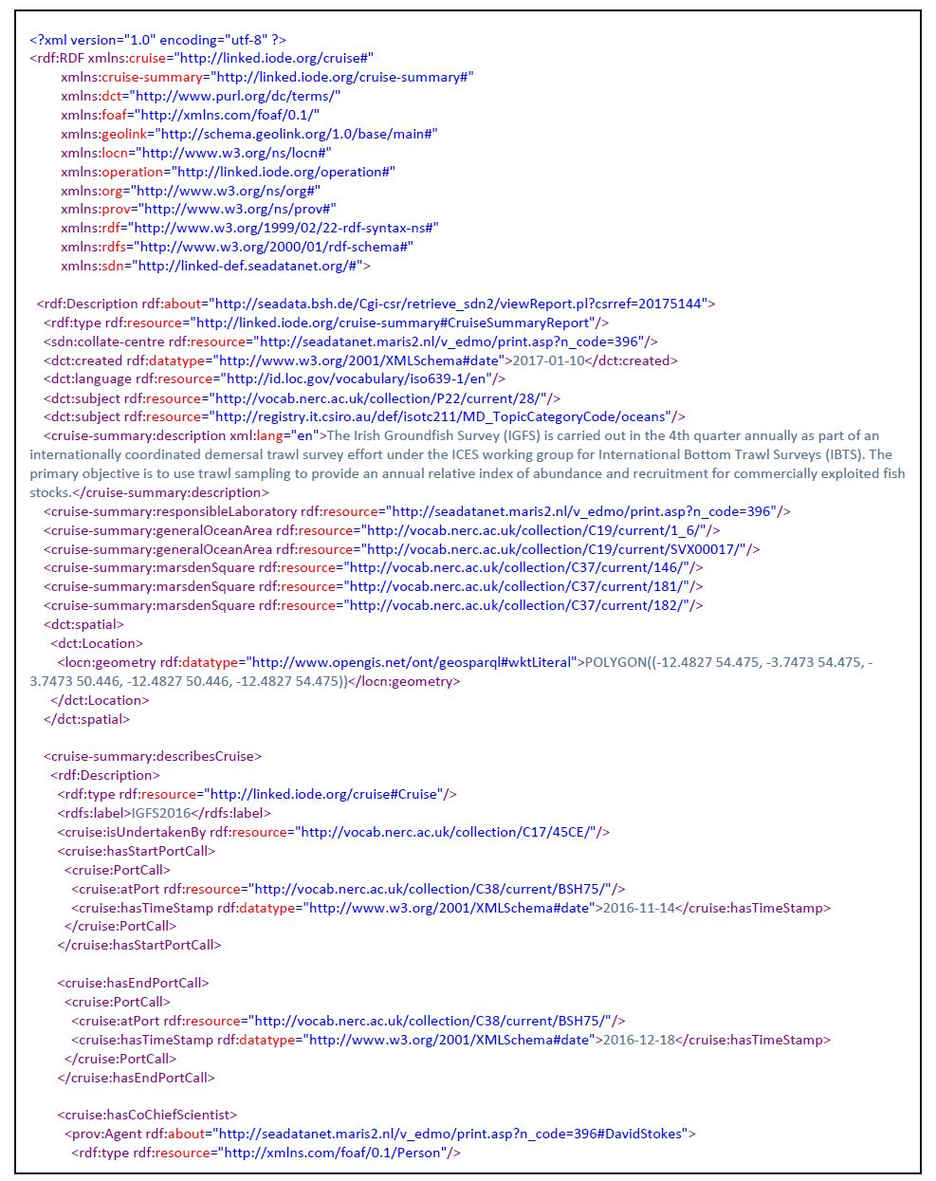
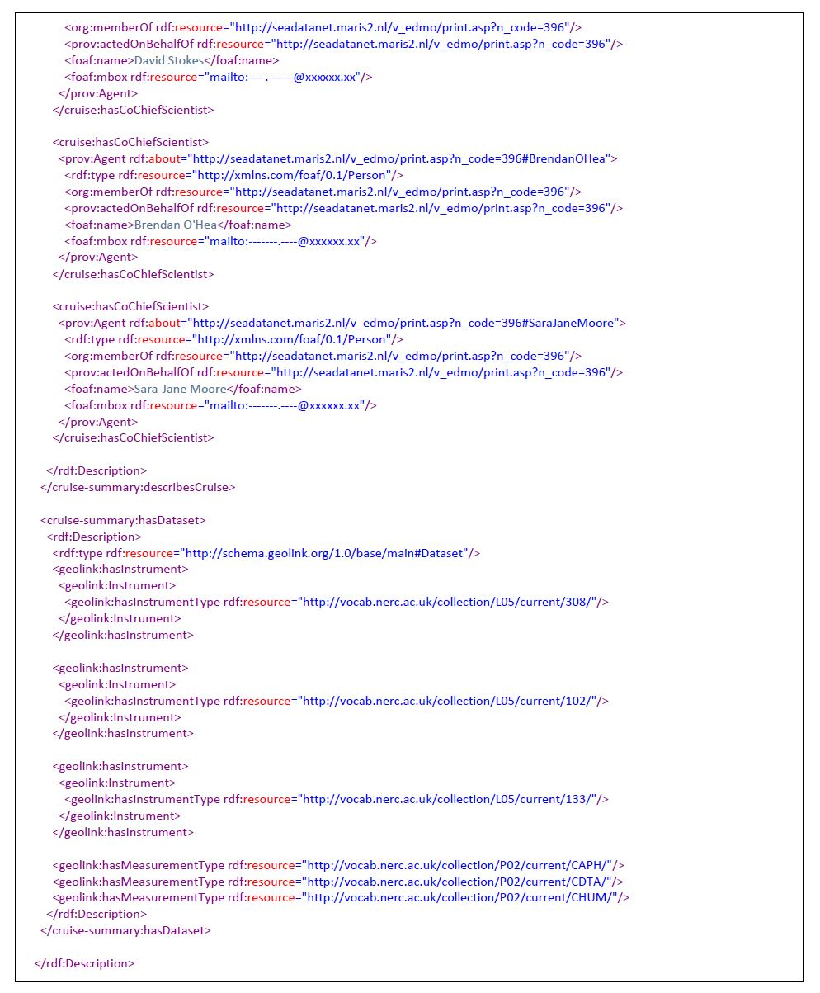
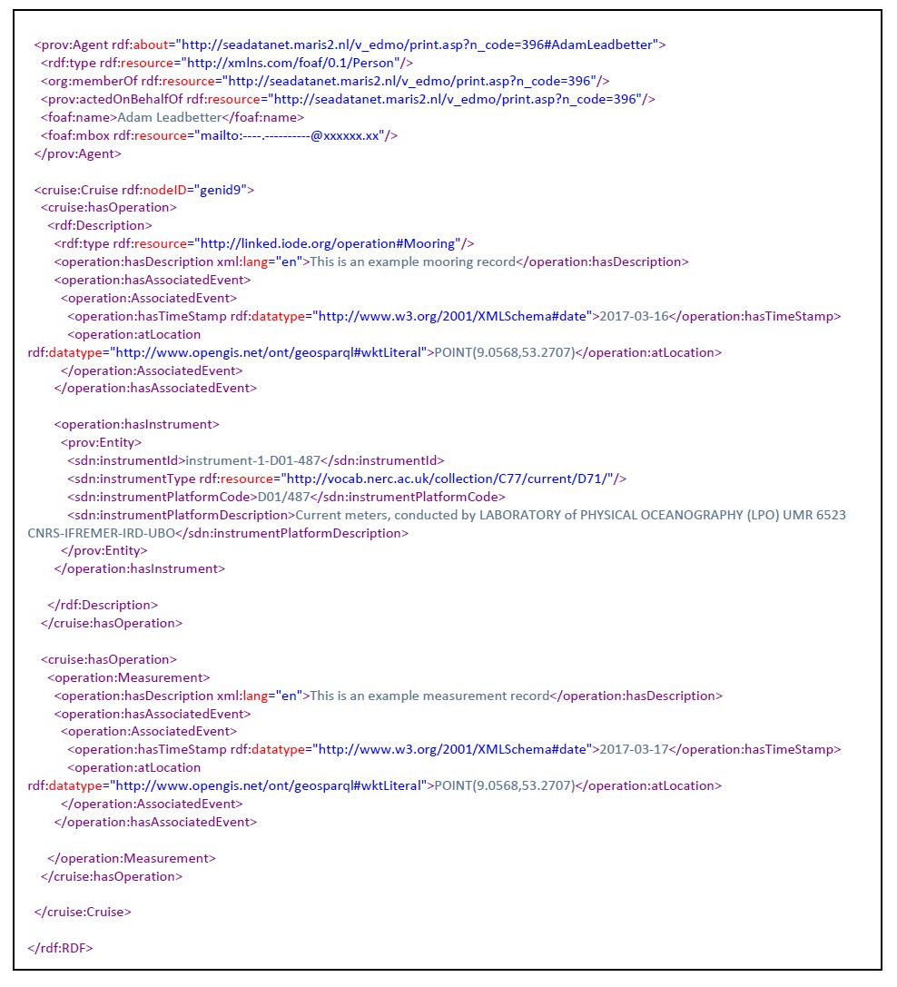

http://xmlns.com/foaf/spec/#term_primaryTopic

